

2012

**Development and Integration of Level-1 Cache RTL Model**

**Supervisors: Professor Macii & Professor Edefors**

**Author: Vahid Saljooghi**

Politecnico di Torino

Electronic Engineering

III FACOLTA' DI INGEGNERIA

Table of Contents

List of Figures 4

List of Tables 5

Acknowledgments 5

Achievements 6

1 Introduction 7

1.1 Motivation 7

1.2 Overview 8

2 Background 9

2.1 State machine naming convention 9

2.2 MIPS 10

2.3 Cache 13

3 Configuration 18

4 Instruction Cache 22

4.1 Controller 23

4.1.1 Constants and Signal Descriptions 23

4.1.2 State transition 26

4.2 Datapath 30

4.2.1 LRU 34

4.2.2 Pseudo Random 38

4.3 Memory handshaking signals-read operation 39

5 Data Cache 44

5.1 Controller 45

5.1.1 State transition 45

5.2 Memory hand shaking signals-read operation 56

5.3 Memory hand shaking signals-write operation 61

6 Arbiter 65

6.1 Controller 65

6.2 Datapath 66

7 System context and cache models 69

7.1 AMBA 71

7.2 DDR Controller and Micron memory 74

7.3 Scripts 76

7.4 Simulation and Synthesize 76

7.4.1 Performance 80

8 Summary 83

8.1 Future work 83

Bibliography 84

# List of Figures

Figure 1: FSM naming convention. 10

Figure 2: Instruction cache interface with instruction fetch stage. 11

Figure 3: Data Cache interface with memory stage. 12

Figure 4: Memory hierarchy. 14

Figure 5: Datapath for direct-mapped cache. 15

Figure 6: 4-Way set associative cache. 16

Figure 7: Instruction cache modules hierarchy. 22

Figure 8: Instruction cache controller FSM. 30

Figure 9: Instruction cache datapath. 33

Figure 10: LRU mechanism. 37

Figure 11: Pseudo random mechanism. 38

Figure 12: Instruction cache handshaking signals for ideal memory access. 41

Figure 13: Instruction cache handshaking signals for non-ideal memory access. 43

Figure 14: Data cache modules hierarchy. 44

Figure 15: Write through with no write allocation flowchart. 46

Figure 16: Data cache write through with no allocation FSM. 49

Figure 17: Data cache write through with allocation FSM. 51

Figure 18: Write back with write allocation flowchart. 52

Figure 19: Data cache write back with allocation FSM. 55

Figure 20: Data cache handshaking signals for ideal memory read. 58

Figure 21: Data cache handshaking signals for non-ideal memory read. 60

Figure 22: Data cache handshaking signals for ideal memory write. 63

Figure 23: Data cache handshaking signals for non-ideal memory write. 64

Figure 24: Arbiter controller FSM. 66

Figure 25: General system level block diagram. 70

Figure 26: AHB controller [4]. 72

Figure 27: AHB/APB Bridge [4]. 73

Figure 28: Detailed system level block diagram. 75

Figure 29: Execution time for different cache sizes and associativities. 81

Figure 30: Execution time for different write policies and cache sizes. 82

# List of Tables

Table 1: LRU table naive design. 35

Table 2: Updated LRU table after a hit happens. 35

Table 3: LRU table for efficient design. 36

Table 4: Instruction cache test. 77

Table 5: Data cache test for write through policy. 78

Table 6: Data cache test for write back policy. 79

# Acknowledgments

Here I should thank two groups for their assistance to make this thesis possible:

First of all, I acknowledge valuable comments and consultancies of professor Edefors and his team at Chalmers University. Although I have been in your group for a short period of time but your friendly acceptance created a long memory out of it. I appreciate long discussions I had with Mr. Sjalander and Mr. Bardizbanyan over finding the best solution for tackles occurring during thesis progress. I enjoyed the opportunity of having two supervisors in different universities and I am grateful that professor Enrico Macii from Politecnico di Torino took the burden of proof reading the report in addition to his helpful feedbacks.

Second of all, my utmost gratitude goes to my family for giving me encouragement to pursue a graduate level career. I would like to thank my mom for her love, my dad for his support and my brothers for tolerating me!

# Achievements

This work has been presented in five universities including: Chalmers University, Lund University, Paderborn University, Politecnico di Torino and Stuttgart University.

The following paper conference and publication is another outcome of this MSc thesis:

* Vahid Saljooghi, Alen Bardizbanyan, Magnus Själander and Per Larsson-Edefors, “Configurable RTL Model for Level-1 Caches”, NORCHIP Conference, November 2012, Copenhagen, Denmark

# Introduction

## Motivation

This work is done at VLSI and computer architecture department of Chalmers University to fulfill their need for a reconfigurable RTL level-1 cache model. The cache model was planned to be used for different projects and in variety of environments. Therefore a configurable model which can be compatible with different processors and memory units was unavoidable. The three main processors that are in use for ongoing projects at Chalmers include: MIPS, FlexCore and roVEX.

Another motivation for this work is its contribution as an open source IP core. One of the examples that make a configurable cache a suitable choice is its application for embedded system design. The processor on most embedded systems runs some specific programs for the entire lifetime of the device, in contrast to desktop processor which supports a range of software applications. Hence a tailored cache configuration which is suitable in terms of miss rate for those specific programs is a rational choice for embedded system applications (For more information refer to [14] and [15]). In addition one issue that is critical in embedded system design is timing and power constraints which a well-chosen cache configuration would have an essential influence on them. Finally having an RTL model, which can be synthesized for an FPGA or ASIC, can assist better understanding of timing issues and hardware area consumption before going to mass production step.

Also having a configurable model in hand, one can do experiments to find out about performance and power consumption before going to implementation stage. This RTL model can also be used as simulator for pedagogical purposes.

Another suitable framework that our configurable RTL model can be used in is ultra-low power processors. It is common to use miniature instruction and data caches in this kind of design which is not an option in commercial market right now. The main task of miniature caches is not to boost performance but to provide significant energy savings as it is shown in [11] and [12].

## Overview

In chapter 2, we consider a general review on concepts that will be referred to in various parts of the report. First we take a look at state machine naming style to clarify our input, output and transition conventions on these machines during text. Next subsection deals with MIPS processor stages and their interface with caches. This will be crucial to learn before going through the details of cache instantiation on system level. Finally, in cache subtitle we cover a basic functionality and structure of cache memory.

Chapter 3 gives a bird’s eye view over configurable parameters of both caches and how one can set these parameters.

In chapter 4, instruction cache design is considered. First, we take a look at controller as heart of the design and then in another subsection datapath is described. The explanation consists of replacement mechanism and cache interface with external memory.

The similar approach as chapter 4 is taken to describe data cache behavior in chapter 5. Since data cache writes into memory additional subsection is dedicated to this capability.

In chapter 6, arbiter component is explained. Like previous modules different subsections are devised for controller and datapath.

In chapter 7, system level implementation is covered. Both caches and MIPS processor are instantiated on system level. In addition there are peripherals like AMBA bus and DDR controller which are essential to set up the environment for simulation and verification. To make the compilation of VHDL codes and applications targeted for MIPS processor easier, some scripts are written which is described in its own subsection as well. Finally, in last chapter we conclude and give some perspective on future work that can be carried out to improve the design.

# Background

## State machine naming convention

A simple two states mealy machine with inputs from first letters of alphabet (a,b,c and d) and outputs from last letters of alphabet (x,y and z) is depicted in Figure 1. We use the same naming convention for all state machines during the text. Each transition is explained in below:

When reset happens (Rst=0), the initial state will be state A. The machine will remain in state A until inputs a equals one or b equals zero, otherwise it transits to state B. With this transition output x activates and all the elements of output vector y changes to one. Machine will remain in state B with a loopback in case input c equals one. As long as input c is equal to one, some elements of output z will be activated. (It is worth mentioning that y=”11…1” means all elements will change to one and z=”…11…” means part of the vector change to one).

With d=1 and a=0, machine returns back to initial state and issues the following output: y=”11…1”. In case input c=1 and at the same time previous expression (d=1 and a=0) is true, another output will be activated which is z”…11…”.

Note: The input and output signals, which are not specifically given in each transaction, are assumed to have default value.

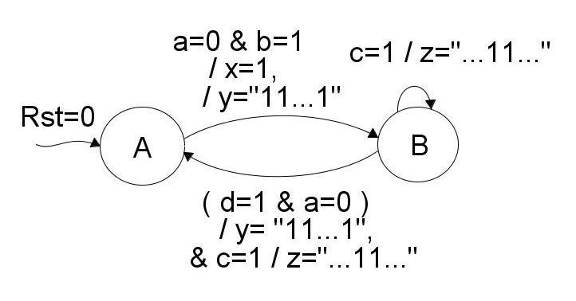

Figure 1: FSM naming convention.

## MIPS

Note: Explaining how MIPS processor works is out of scope of this document. Only crucial parts that may help understanding processor and cache communication are covered. For more information please consult bibliography section [2].

Although caches are designed as reconfigurable components and can be used with variety of processors but the main processor used for testing (verification) the functionality is MIPS processor.

MIPS is a pipeline processor with five stages (Instruction fetch, Decode, Execute, Memory and Write back). The two stages that caches have a lot of interaction with are: instruction fetch and memory stages. Instruction cache and data cache are instantiated in instruction fetch and memory stage respectively.

Instruction cache instantiation in IF Stage:

In IF stage PC register provides inst. cache with address of instruction needed by processor at each clock cycle. Since cache memory is also synchronized with clock, to reduce one clock cycle for accessing the cache, the value of program counter before registering is passed to cache (PC_Comb). As depicted in Figure 2 the value of PC before registering is named PC_comb to indicate the combinatorial nature of signal.



Figure 2: Instruction cache interface with instruction fetch stage.

Data cache instantiation in memory stage:

In memory stage values that are needed by data cache includes: ALU result which provides address to data cache, Read signal to command read operation, Write signal for doing write to memory and finally, data from processor in case of writing to memory.

Like instruction cache, data cache memory is synchronized with clock. Since pipeline register between execute and memory stage also operates with clock (sequential component), these two components in sequence will introduce excessive clock usage during operation. To reduce additional clock cycle, as it is shown in Figure 3, combinatorial version of ALU result, Read and Write signals are also delivered to data cache.



Figure 3: Data Cache interface with memory stage.

Forwarding:

Another aspect of MIPS processor is its support for forwarding to avoid processor stalling. To learn the mechanism for forwarding consider following example:

Assume 3 instructions in a sequence, which could be extracted from a longer application, should be executed by processor:

Add $2,$3,$4

SubI $4,$3,1

AddI $5,$2,3

The last instruction execution relies on the result from the first one ($2). In pipeline stages when last instruction is in execute stage the first one is in write back stage. If forwarding is not supported by processor, because of data hazard processor should stall for one clock cycle until $2 is written back to register file. With forwarding there is no need to stall processor and content of $2 would be forwarded to execute stage before writing into register file.

## Cache

Note: In this part operation of cache is not described with details. To learn how cache works; it is recommended to refer bibliography section ([1], [2] and [3]).

Introduction:

Cache is small and fast memory near processor. Since memory technology to make a cache is expensive, it is not possible to make whole main memory out of cache memory technology. Therefore in current computer architectures there is a variety of memories with different latency and capacity that form a hierarchy as shown in Figure 4. Access to smaller cache size is faster and that is the reason for having hierarchy level among caches as well. Fortunately, because of software programs nature, it is not necessary to have all the instruction and data available for processor to be able running the application. This is also known as locality of reference that can be divided to two categories spatial locality and temporal locality. For many years computer architectures have used memory hierarchies as a trick to exploit these principles. Part of the program instruction or data that is needed by processor in near future will be loaded from cheaper, bigger and slower memory to more expensive, smaller and faster one ahead of usage. In this way processor feels that it accesses a fast memory without having knowledge of slower ones in the hierarchy.

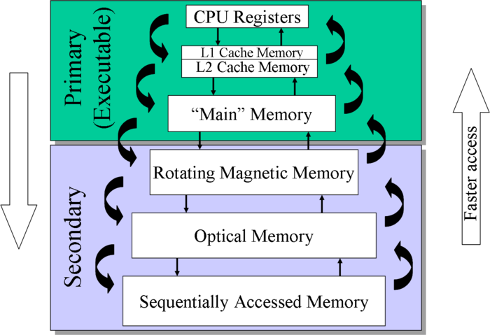

Figure 4: Memory hierarchy.

The scenario mentioned above is not always true and sometimes CPU should wait (stall) for slower memories in the hierarchy. One occasion is when for very first time processor wants to start running a program. Since cache is not loaded with data of application prior to execution, there will be cache miss and data should be transferred from lower memory to cache (This kind of miss is also known as compulsory or cold miss). Also because of limitation in size of cache some data should be replaced by newer ones during program execution. If processor request for replaced data later a conflict miss will happen and data should be retrieved from memory again.

Based on processor architecture it is possible to have a single cache or two separate caches. In case of two separate memories for data and instruction (Harvard architecture), using two caches for each memory is suggested. Instruction cache only reads from memory compared to data cache which can both read and write into memory. To make the design usable by single unit memory architectures, it is possible to utilize an arbiter to choose between caches.

Cache structure:

Since cache memory is smaller than lower level main memory, there should be a scheme to map data coming from memory into cache. One way is to put each memory block into a specific cache block (Direct-mapped). Another way is to freely choose a set of cache (Fully associative). Finally the last option is something intermediate of previous mentioned solutions that is to first choose a set (row) of cache and then freely use a block in that specific set (set associative). Figure 5 shows a datapath for direct-mapped cache.

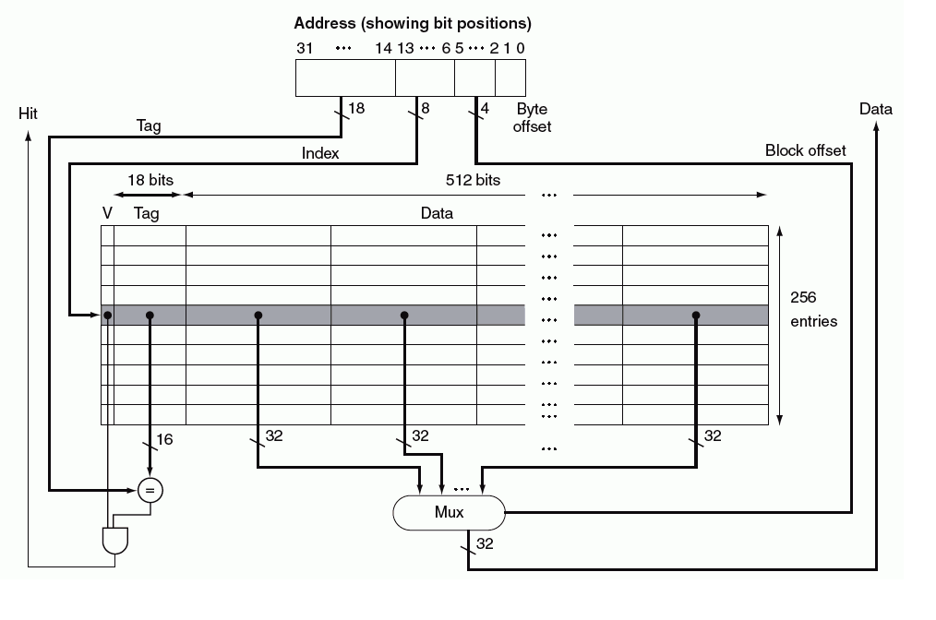

Figure 5: Datapath for direct-mapped cache.

As it can be seen, cache is composed of Tag and Data part (array). Data part stores a block of memory. A block itself would contain more than one instruction/data. To understand Tag part; first we should take a look at PC register. As shown on top of the picture PC register is divided into 4 fields. First field as its name indicates selects byte offset in a word. After choosing one of the words in a cache block, a second multiplexer which is not shown in the picture will choose the byte offset (Byte offset is only for data cache and it is not applicable to instruction cache). Third field (index field) works as an address to select appropriate row. At the end since there could be more than one memory block mapped into a location (row) of cache, to distinguish between them Tag part comes handy. After comparing content of Tag part of cache with value in PC tag field if they match and valid bit of that set is one then a hit happens otherwise it is a miss and data should be transferred from lower level memory to cache.

As long as cache is a direct-mapped there is no need to worry about replacement policy. Since each block of memory maps into a specific row in the cache, in another words the victim that should be evicted is determined. In contrast for a set associative cache there should be a policy to choose the victim line. For example as shown in Figure 6 in a 4-way set associative cache, after finding specific row there are four options to put the block. If an empty way is available, it will be used to hold the block otherwise one of the ways should be chosen to replace. The best algorithm for replacement predicts which block in a set (row) is not likely to be used in near future. Predicting future is not possible so algorithms currently in use try to approximate it. Least Recently Used (LRU) and Pseudo random are two examples.

One drawback of set associative cache is its latency to find a requested value comparing to direct-mapped cache. Therefore associativity number will not exceed a certain value.

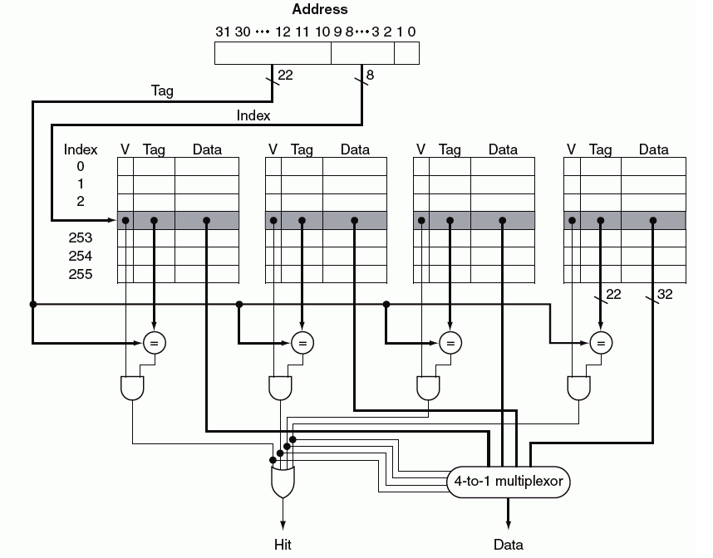

Figure 6: 4-Way set associative cache.

The last issue which is only applicable to data cache (not instr. cache) is write policy. Basically, there are two options to write into cache when a hit occurs: one is to write only in cache and put a dirty flag (status bit) on that set to indicate that this set is not stored back in lower memory in the hierarchy. Whenever a set should be replaced by another memory block if it is dirty, it will be first stored back to lower memory unit otherwise it simply replaced by new block (Write back or copy back policy). Another alternative is to write both in cache and memory at the same time (Write through policy). In case a miss occurs for each of above mentioned policies, it is possible to allocate or not allocate a place in cache. The more common policies are: Write through without allocation and Write back with allocation.

# Configuration

Currently two replacement policies are supported: LRU and Pseudo random. Since caches are designed in a modular manner, one can easily add other replacement policies such as Pseudo LRU based on application. Write policies supported include write back with allocation and Write through with and without allocation. Maximum associativity that can be set is 4, although it is possible to increase it with small modifications in LRU calculation mechanism.

Both caches are developed to be configurable. Therefore they can be used in processors with arbitrary data and address bus lengths and they can communicate with variety of external memory widths. All configurable parameters are collected in “Constant.vhdl” file. Each of them is described as bellow:

Processor parameters:

Address_Space_CPU: It holds CPU address bus width (PC size).

Data_Bus_Width: It holds CPU data bus width (ALU output size in most processors).

Instruction and data memory parameters:

Ideal_Mem: If memory responds without any delay, it's an ideal one and this Boolean value should be set to true.

DMem_Width: Stands for data memory width. If there are separate data and instruction memories this value can be different from IMem_Width.

Address_space_DMem: Length of data memory address. If there are separate data and instruction memories this value can be different from Address_space_IMem.

IMem_Width: Stands for instruction memory width. If there are separate data and instruction memories this value can be different from DMem_Width.

Address_space_IMem: Length of instruction memory address. If there are separate data and instruction memories this value can be different from Address_space_DMem.

Parameters common between data and instruction cache:

LRU: Stands for least recently used. This constant is not modifiable. It is used merely as an alias for an integer numbers to increase readability and ease of use. The number assigned to it is zero.

PseudoRan: Stands for pseudo random. This constant is not modifiable. It is used merely as an alias for an integer number to increase readability and ease of use. The number assigned to it is one.

LFSR_Width: To produce a pseudo random number a linear feedback shift register is used. By changing its width, LFSR randomness aspect will increase.

Data cache parameters:

WrThrNoAlloc: Stands for write through with no allocation. This constant is not modifiable. It is used merely as an alias for an integer number to increase readability and ease of use. The number assigned to it is zero.

WrThrAlloc: Stands for write through with allocation. This constant is not modifiable. It is used merely as an alias for an integer number to increase readability and ease of use. The number assigned to it is one.

WrBackAlloc: Stands for write back with allocation. This constant is not modifiable. It is used merely as an alias for an integer number to increase readability and ease of use. The number assigned to it is two.

DC_Write_Policy: It holds write policy for data cache and can be set to WrBackAlloc, WrThrAlloc or WrThrNoAlloc.

DC_Num_Of_Ways: It shows number of ways for data cache and the maximum value for it is 4.

DC_Rep_policy: It defines replacement policy for data cache. Currently it supports two common policies: PseudoRan and LRU.

DC_Num_Of_Sets: It contains number of rows for data cache (depth of cache).

Words_in_Block: It holds number of words in each data cache line or cache block.

Word_Size: Since in different processors word size varies, based on processor one can set length of word in bits.

DC_Data_Mem_Width: Data part of cache composes of multiple syncrams with equal width. This value contains width of each syncram. The value should not be mistaken with DMem_Width. DMem_Width denotes to width of main memory. Hence it is a memory parameter. In contrast

DC_Data_Mem_Width indicates width of memory which composes data part of cache and it is a data cache parameter. (Note: since cache neither uses buffer nor memory with mask, DMem_Width is always greater than or equal to DC_Data_Mem_Width)

DC_LRU_Table_Width: To keep track of which way is least recently used, a memory table is unavoidable. Width of table varies depending on number of ways.

DC_Index_in_Bits: Number of bits for cache index that is calculated using log2(DC_Num_Of_Sets).

DC_Block_Offset_in_Bits: Number of bits for offset that is calculated using log2(Words_in_Block).

DC_Block_Size: It holds block size in bits and is equal to Words_in_Block*Word_Size;

DC_Bytes_in_Word: It holds number of bytes in each word (Word_Size/8).

DC_Byte_Offset_in_Bits: Number of bits required for byte offset which is calculated by log2(DC_Bytes_in_Word).

DC_Block_Size_in_Byte: Number of bytes inside a cache line which is calculated by DC_Block_Size/8;

DC_Tag_Size: Part of data memory address (In MIPS processor is ALU result) is devoted to tag size. The length of tag size is stored in DC_Tag_Size and can be obtained by reducing offset and index bits from data bus width (Data_Bus_Width-DC_Index_in_Bits-DC_Block_Offset_in_Bits-DC_Byte_Offset_in_Bits).

DC_Num_Data_Mem: It holds number of syncrams that is needed to cover cache line and is calculated with this formula: DC_Block_Size/DC_Data_Mem_Width.

DMem2DataWRatio: DMem_Width/DC_Data_Mem_Width;

Num_DMem_Refer: It contains number of times that data cache refers to main (data) memory to load a cache line. After deciding about cache line size and memory width this value will automatically be set using this formula: DC_Block_Size/DMem_Width.

Instruction cache parameters:

Parameters for instruction cache are similar to data cache. Since instruction cache constants are similar to their counterpart in data cache, to avoid a long documentation, parameters description for instruction cache is not repeated. To differentiate between data cache and instruction cache constants, DC and IC are used as prefix respectively.

# Instruction Cache

Like most hardware designs instruction cache is divided into two major parts: Controller and Datapath. As it is depicted in Figure 7, the controller part is implemented in IC_Controller VHDL file. The remaining is Datapath part which can be categorized in two important groups. One group is instruction cache memory (ICache_Mem) and second group includes components related to replacement policy algorithms (LRU and Pseudo Random).



Figure 7: Instruction cache modules hierarchy.

Since controller is heart of the design we take a look at it first in next section.

## Controller

Before going through details of controller implementation it is helpful to get familiar with input and output ports plus constants that are used in IC controller. Then will take a look at state machine and its transitions.

### Constants and Signal Descriptions

The following signals and constants are collected in a package with the name: IC_Controller_Pack

Constants:

Num_IMem_Refer: Indicates number of instruction memory refers by cache to load a block. Its value depends on memory width and each cache line (block) size. As an example for a cache line of four 32-bits instructions and main memory width of 16 bits, Num_IMem_Refer will be equal to 8.

IC_Num_of_Sets: Number of sets or rows in cache (Height of cache).

IC_Num_Data_Mem: Number of syncrams needed to cover cache line size. For example if syncrams width is 8 bits and cache line consists of four 32-bits instructions then IC_Num_Data_Mem is equal to 16.

Note: Data in IC_Num_Data_Mem refers to Data part of cache (compared to TAG part) and should not be mistaken for data (main) memory.

Input signals: are collected in a VHDL record type as shown below:

Type Controller_in_type is record

Extr_Stall : std_logic;

ready_IMem : std_logic;

hit : std_logic;

End record;

Extr_Stall: This signal comes from processor. If we look from instruction cache perspective two kinds of processor stall are possible: one is internal stall which is due to cache miss from instruction cache. As a result inst. cache will be loaded with requested memory value. Second kind of stall is external stall which is not caused by instruction cache. Examples of such stalls are: unresolved data hazard stall in MIPS processor or data cache miss which in turn cause processor stall until data cache hits.

ready_IMem: This signal comes from main (instruction) memory. In case of a cache miss it’s the responsibility of cache to request main memory for an entire block. Each time an instruction or part of it returns back from main memory, cache receives a ready signal along with the data. As soon as cache receives the ready signal from memory it asks for next instruction (or part of instruction) in the block.

hit: This signal comes from cache datapath. A comparator will issue this signal after comparing TAG part of program counter with value of TAG stored in the cache. If both values are equal hit signal will be activated else it will be zero.

The outputs are also gathered in a VHDL record type as follow:

Type Controller_out_type is record

counter_Mem : natural range 0 to Num_IMem_Refer-1;

counter_flush : natural range 0 to IC_Num_of_Sets;

Re_IMem : std_logic;

en_flush : std_logic;

en_cache_Data : std_logic_vector(IC_Num_Data_Mem-1 downto 0);

write_cache_Data : std_logic_vector(IC_Num_Data_Mem-1 downto 0);

en_cache_Tag : std_logic;

write_cache_Tag : std_logic;

Mem_Acc_Finished : std_logic;

end record;

counter_Mem: This signal will be used by instruction cache datapath. To load the line of cache from memory usually there will be more than one access to memory depending on memory width and number of instructions in a block. For example if we have a memory with 16 bits width and the size of block is 4 instructions (Each instruction is 32 bits), to read the block from main memory there will be 8 accesses to it.

Counter_Mem will counts number of accesses to memory to find out when the request should be terminated. In addition it will be used as an offset to produce consecutive memory addresses (It will be added to first address of instruction in a block. Since it is incremented by one each time memory returns back a ready signal, the consecutive addresses can be produced).

counter_flush: This signal will be used by instruction cache datapath. Before using the cache we should clear TAG values in the cache to avoid undesired cache hit due to random values already in the TAG part of cache.

counter_flush value work as address to TAG memory. It goes through all the sets (rows). In case of having a set-associative cache, this signal will be passed as input to each way.

Re_IMem: This signal will be used by main (instruction) memory. As the name implies whenever cache asks for a data from memory, read signal of memory goes high (It works as command signal).

en_flush: This signal will be used by instruction cache datapath. During normal operation of cache address and data to TAG memory are index part and TAG part of PC respectively. To flush cache the flow should change using some multiplexers which en_flush is select signal for them. During flush mode address steers to counter_flush. Also the data value that is written to TAG memory changes to zero.

en_cache_Data: This vector signal will be used by instruction cache datapath. As mentioned earlier cache memory consists of TAG and Data part. Data part itself is composed of syncram modules with equal width. For example assume each cache line (block) is 4 instructions (each instruction is 32 bits). To cover the whole block we need 8 syncram with 16 bits width. Each syncram has enable signal which makes the size of vector equal to 8 for our example. Depending on instruction (or part of instruction) number that comes from memory block the corresponding syncram will be enabled to capture the instruction (or part of instruction).

Note: Since there is no buffer between main memory and cache and syncram is not maskable memory the width of syncram cannot be wider than memory width.

For more info refer to waveform diagrams in Figure 12 and Figure 13.

write_cache_Data: This vector signal will be used by instruction cache datapath. Explanation is similar to en_cache_Data. Each syncram needs a write signal. To be able to write in syncram both enable and write signal should be activated at the same time.

For more info refer to waveform diagrams in Figure 12 and Figure 13.

en_cache_Tag: This signal will be used by instruction cache datapath. A separate syncram will be used to store TAGs. Syncram width depends on TAG length of program counter. To read/write from syncram this signal should be activated.

write_cache_Tag: This signal will be used by instruction cache datapath. To update the TAG content, cache controller activate write signal in addition to enable signal of syncram.

Mem_Acc_Finished: This signal will be used by Arbiter. As soon as memory access by instruction cache is finished, cache controller will raise this signal (To notify that main memory is released). It will be used by arbiter to schedule main memory between instruction and data cache access.

### State transition

As shown in Figure 8 controller is a 3 states mealy machine. Mealy machine has the advantage of producing outputs based on current state and inputs (In contrast to Moore machine that outputs are determined solely by its current state). Having clock synchronous components in the design makes mealy machine a good choice. Signals before slash are inputs to controller and signals after slash are outputs. To reduce complexity, some of output signals which change value are shown in each transition and default values are assumed for remaining output signals.

For more info on transition naming refer to state machine naming convention section.

Each state and its transitions are described below:

Flush: the initial state after resetting the cache is flush. Its goal is to clear out TAG memory of cache. One may ask why all the TAG bits and not just valid bit? The answer is: To store valid bit two schemes is possible. One is to use a flipflop with reset for each set (row) and the other is to store valid bit alongside TAG bits in a memory. We choose second solution for following reasons: First solution has the advantage of resetting all valid bits in one clock cycle (reset all flipflops together) besides it is possible to invalid a cache block more easily (This capability is useful for caches in shared memory environment. As soon as a memory block is updated by another entity, corresponding location in the cache can be easily put to invalid).

Second solution consumes less area compared to using flipflop scheme but it takes number of sets (rows) clock cycle to set the TAGs to zero (Reminder: There is no reset signal for syncram therefore one should manually write zero into it in a loop).

The loop back transition: stays in flush until all TAGs are cleared (counter_tmp < IC_Num_Of_Sets). This means that a counter counts for all the number of sets and write zero into TAG part (array) of cache.

Since TAG part is made of a syncram, corresponding signals which should be decided by cache include: enable, address, data and write signal. During flush mode address and data should change to counter value and zero respectively that’s why we need a control signal to select a multiplexer to steer the path. Name of the control signal is en_flush. Another signal is for enabling counter to count for number of sets (en_counter_flush=1). To use resources efficiently there is only one counter in controller. Counter output will be sent through two different signals (Since one of the signals is active and uses counter result at a time, having two signals instead of one has the advantage of reducing switching activity on nodes). One signal which is used in flush state works as an address to TAG (counter_flush). The other one is offset for main memory address (counter_Mem) which we return back to it later.

Transition to Comp_Tag state: after all the TAGs in the cache are set to zero controller change its state to comparing tag. To do so enable signal of TAG syncram is activated (en_cache_Tag=1). Also all the enable signals of cache data part are activated to read one block of cache (en_cache_Data=”11..1”). In this way if the request is hit, processor will use the fetched data from cache and if it is miss, data value is ignored (discarded). The last signal, which is an active low signal, resets counter (rst_counter=0). Since counter is a shared resource that will be used later to count number of memory accesses in Read_Mem state, it is necessary to reset it after finishing using it.

Comp_Tag: in this state based on index part of PC, a TAG value is obtained from cache and is compared with TAG part of PC. If values are equal hit occurs and PC goes to next instruction otherwise a miss happens and processor will stall until missing instruction loaded from main (instruction) memory.

Loop back transition: if there is a hit, next state will be Comp_Tag again and signals to read Tag and Data parts of cache will be activated (en_cache_Tag=1, en_cache_Data=”11..1”) to able comparing for next PC request. There is another loop back transition in this state which will not activate any output signals. This will happen when condition: FirstTime=0 and Extr_Stall=1 exists. To explain the reason for having this condition consider following situation:

Assume there are separate instruction and data memory in processor (Harvard Architecture) so instruction and data caches read from their own memory. Also assume size of a block in instruction cache is much smaller than data cache and both of them request for a missing data to memory. The instruction cache will be loaded much earlier than data cache and returns back (from Read_Mem) to Comp_Tag state. In other words instruction cache missing instruction resolves faster than data cache missing word. At this time FirstTime is zero since instruction cache has read from memory for one time. To reduce power consumption, instruction cache will stay in the comp_Tag state without activating read signals of TAG and Data part of cache. Because these signals are needed to able comparing next PC not activating them is not destructive as long as there is stall in processor (Remember because of data cache miss, processor is in stall and will not request for a new instruction). This condition will continue until Extr_Stall that is produced by data cache is deactivated. Now enable signals for Tag and Data in instruction cache can be issued to pave the way for next PC comparison.

Transition from Comp_Tag to Read_Mem: If cache miss occurs next state will be reading from memory.

Re_IMem is activated to request read command to memory. Another signal that works as a flag to arbiter (Mem_Acc_Finished) is set to zero to indicate that main memory is captured by instruction cache. Last signal enables counter to count for number of memory accesses (en_counter_Mem=1)

Read_Mem: Reading from main memory occurs in this state. Each time cache do a memory request a data value returns back from memory. Depending on memory width it can be part of an instruction, whole instruction or even number of instruction in one memory access. Cache uses Num_IMem_Refer constant to know how many times (maximum) it should refer to memory. As long as number of refers are less than Num_IMem_Refer, controller stays in Read_Mem state and when it reaches Num_IMem_Refer, it will return back to Comp_Tag state.

Loop back transition: As explained above first loop back stays in Read_Mem until last word of the block reaches (counter_tmp < Num_IMem_Refer-1). To read from memory two signals are necessary. One of them enables (Re_IMem=1) it and the other one is address of location in need. counter_Mem is the offset for memory address and will increased by one whenever memory returns a data (counter_Mem=counter_tmp+1). Since there is no buffer between memory and cache, data coming from memory should be written to cache immediately. To do so some (depending to memory width and syncram width) of the syncrams that compose Data part of cache should be enabled (en_cache_Data=”…11…”, write_cache_Data=”…11…”). To reduce power, cache enabling can happen exactly after getting data from memory (ready_IMem=1), instead of enable writing into cache for a whole time. Finally, because memory is being used by instruction cache, the flag (Mem_Acc_Finished=0) is raised to inform arbiter that memory is grabbed by instruction cache.

For second loop back to occur these conditions should meet: counter_tmp=Num_IMem_Refer-1 and ready_IMem=0. This means cache is still waiting for the last word of the block. So enable port and address line of memory is being derived by cache (Re_IMem=1, counter_Mem=counter_tmp).

Transition to Comp_Tag: As soon as the last word of block arrives (counter_tmp=Num_IMem_Refer-1 and ready_IMem=1) transition to Comp_Tag takes place. In addition to enabling Data part of cache (en_cache_Data=”11..1”, write_cache_Data=”…11…”) to put last word in it, TAG part is also enabled to update the TAG (en_cache_Tag=1, write_cache_Tag=1). It is worth mentioning that all elements of en_cache_Data are enabled. As a result the line of cache that just has been loaded from memory can be read. Later using a multiplexer the missing instruction will be chosen among whole cache line and will be delivered to processor.

In current design thanks to syncram it is possible to write first and then read at the same clock edge. In case of using other kind of memory that cannot support write and read at the same clock edge additional state between Read_Mem and Comp_Tag is necessary to give enough time for writing first before reading happens.

Note: For more clarification, please refer to transition naming convention of FSM and handshaking waveform signals for memory access.

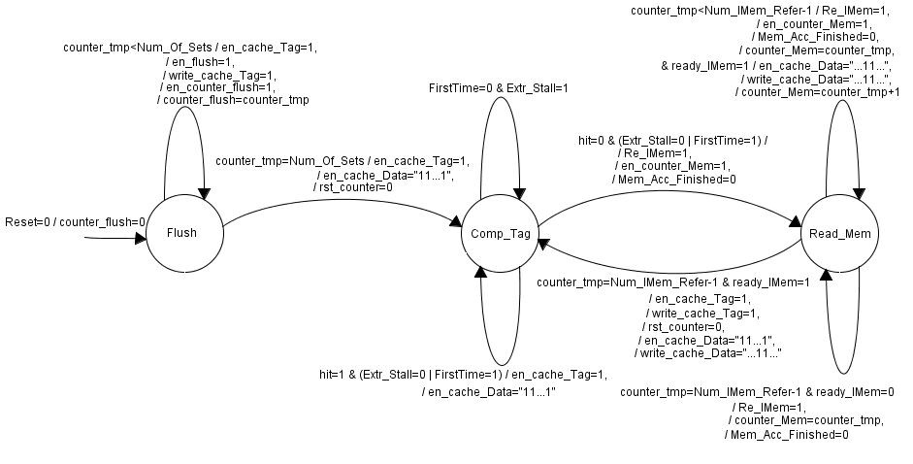

Figure 8: Instruction cache controller FSM.

## Datapath

As it is mentioned and shown earlier in Figure 7 instruction cache is divided to controller and datapath. The controller part which produces control signals for datapath has already covered. In this segment we consider important signals between cache and processor, cache and memory. Also we take a look at internal wiring of cache memory.

The datapath for a specific configuration is shown in Figure 9. The configuration is as follow:

Associativity: 4 ways

Number of rows: 1024

Cache line capacity: 2 instructions per line

Syncram width: 16 bits

Main memory width: 32 bits

Replacement policy: LRU

It is helpful to mention that most of the dangling signals come from controller. The explanation comes with components order from left hand side to right hand side of figure. The first register is PC that produces the address to cache. When PC is enable with each clock cycle it requests a new instruction from cache. There are three cases for PC to be disabled: First potential is when instruction cache does not have the requested instruction inside (hit=0). Second possibility happens when data cache is not ready (ready_DCache=0). Since data cache tries to deliver processor with data for previous instruction, processor stalls. As soon as processor stalls, instruction cache should remain on its current request instead of going to serve the next request. If instruction cache goes to serve the next request (using PC_Comb instead of PC), the current instruction will be discarded without even being fetched by processor. The third case which stalls processor as its name indicates is when hazard stall occurs (Hazard_Stall=1). There are occasions that stall is not avoidable even by resorting to forwarding scheme. In this case PC disables and instruction cache remains on its current request.

In this paragraph tag inputs are explained. Tag part of PC is 21 bits. This 21 bits concatenated with valid bit compose data for tag memory. The address for tag memory is index part of PC which chooses specific row among 1024 rows. The reason for having multiplexers at the input of data and address of tag is to make flushing of cache possible. When cache is in flush mode (en_flush=1), the zero value will be chosen as data for tag. Also address value goes through whole the row of cache in a loop (counter_flush). It is needless to say that counter_flush is produced by controller.

Another usage of index part of PC is as an address for LRU table. Since for each cache row, we keep track of accesses to ways, the depth of LRU table is equal to the depth of cache memory (Which in our example is 1024). In addition to read address, LRU table needs a write address to update its current LRU status. The reason for having two address ports is for LRU table to read next LRU at the same time that it updates previous LRU. Without two address ports, processor should stall. To read from LRU table, read address (Read_Addr) and enable signal (en_LRU) should be provided to table. It is obvious that reading current LRU occurs synchronized with reading cache tag for comparison. Therefore enable signal of LRU table is dependent on en_cache_tag signal. Since en_cache_tag signal is activated during update of tag memory, we used write_cache_tag signal to mask it at this specific moment.

The occasion for writing into (updating) LRU table is when a hit happens. That is why Wr_LRU signal is connected to hit signal. As it can be seen write address is buffered using a register. This buffering of address makes it possible to serve the next processor request meanwhile updating the LRU table.

At the end it is worth mentioning that to choose the requested instruction by processor two levels of multiplexing is necessary. First multiplexer selects the way which is recently hit. Second multiplexer chooses the corresponding instruction based on the offset of PC register.



Figure 9: Instruction cache datapath.

### LRU

One of the issues for LRU policy is its efficiency for high associativity. As explored in [13] there are tradeoffs between different implementations. One of the important parameters for us is memory footprint of storing LRU table. Therefore we used a mechanism similar to counter implementation described in [13]. It should be mentioned that this scheme is exploited in Leon processor cache too [5].

To find the least recently used way between numbers of ways, we need at least three different components: One should keep record of current usage of (access to) ways. It is nothing more than a simple memory which is named LRU_Table in our design. Second module should do the calculation to find the next LRU state. It will do it based on current LRU state and the way number which recently a hit occurs for it. The component name is LRU_Cal. Third module chooses the victim way based on current LRU state. The module that does the task is named LRU_Rep. In following we describe each of them with detail:

LRU_Table:

The best way to learn how LRU_Table works is by using an example. We first take a look at a naive design which makes understanding of the efficient one easier.

Assume we want to keep LRU record of a 4-way set associative cache which has 8 rows (The index length of PC register is 3 bits). We can make a table as shown in Table 1. The lower value means that way is the least recently used way for specific row. For example for index 5, way 3 is the LRU. To store a row, we need 8 bits (For each way we need 2 bits).

|  |  |  |  |  |
| --- | --- | --- | --- | --- |
|  | Way 3 | Way 2 | Way 1 | Way 0 |
| Index 0 | 3 | 0 | 1 | 2 |
| Index 1 | 1 | 3 | 2 | 0 |
| Index 2 | 3 | 2 | 0 | 1 |
| Index 3 | 2 | 1 | 3 | 0 |
| Index 4 | 3 | 2 | 0 | 1 |
| Index 5 | 0 | 2 | 1 | 3 |
| Index 6 | 0 | 3 | 2 | 1 |
| Index 7 | 3 | 0 | 1 | 2 |

Table 1: LRU table naive design.

Now assume a hit happens in a specific way for each row (The hit way is added to the last column of table. It is not necessary to mention that Hit Way is not part of the LRU table and it is an input to the table). The updated version of table is shown in Table 2. To update the table one approach is to first read the row and then put the maximum value for way that recently hits. Decrease value of other ways by one and keep in mind not doing it for value zero. The drawback of this algorithm, in addition to its complexity, is usage of extra hardware (adder/subtractor).

|  |  |  |  |  |  |
| --- | --- | --- | --- | --- | --- |
|  | Way 3 | Way 2 | Way 1 | Way 0 | Hit Way |
| Index 0 | 2 | 0 | 1 | 3 | Way 0 |
| Index 1 | 1 | 3 | 2 | 0 | Way 2 |
| Index 2 | 3 | 2 | 0 | 1 | Way 3 |
| Index 3 | 2 | 1 | 3 | 0 | Way 1 |
| Index 4 | 2 | 3 | 0 | 1 | Way 2 |
| Index 5 | 3 | 1 | 0 | 2 | Way 3 |
| Index 6 | 0 | 2 | 1 | 3 | Way 0 |
| Index 7 | 2 | 3 | 0 | 1 | Way 2 |

Table 2: Updated LRU table after a hit happens.

There is another approach to keep track of LRU way which is more efficient in memory usage. To make it possible, first we do two levels of hardware encoding which can be found in LRU_Cons_Pack. For all the permutations (possibilities) of LRU, we assign a unique binary code. For our previous example the table will be modified as shown in Table 3. For clarification consider index 3 which value w2130 is stored in it. This means that Way 1 is the most recently used and Way 0 is the LRU. In this mechanism for all the permutations, we should define a binary number. Since for 4-way associative there are 4!=24 possibilities, we need at least 5 bits which can be derived by this formula: Ceiling[log2(4!)]. Comparing to previous naive design, now we need only 5 bits for each row.

|  |  |  |  |  |
| --- | --- | --- | --- | --- |
|  | Way 3 | Way 2 | Way 1 | Way 0 |
| Index 0 | w3012 | | | |
| Index 1 | w1320 | | | |
| Index 2 | w3201 | | | |
| Index 3 | w2130 | | | |
| Index 4 | w3201 | | | |
| Index 5 | w0213 | | | |
| Index 6 | w0321 | | | |
| Index 7 | w3012 | | | |

Table 3: LRU table for efficient design.

To calculate new LRU when a hit happens, we populate a table of constants with the name lru_4way_table. This table will be used by LRU_Cal VHDL file. To learn how it works, first and second row of table is extracted and pasted below:

First row of lru_4way_table: (w3012, w0312, w0132, w0123), -- w0123

Second row of lru_4way_table: (w3021, w0321, w0132, w0123), -- w0132

For LRU calculation two values are needed by LRU_Cal module which is passed to it as an input. First input is current LRU state that comes from LRU_Table. This value chooses the row of lru_4way_table and is shown as comment in front of each row. As an example w0123 with binary code of “00000” points to first row and w0132 with binary number of “00001” points to second row. Second input is the way that is recently hit. It can be any of the 4 ways. Based on hit way and current LRU, next LRU will be selected from table. For example consider that in LRU_Table the value of w0132 is stored for a specific index (row). That means way 1 is most recently used and way 3 is LRU. Now a hit happens in way 2 and LRU_Cal should find new value for LRU and update the value of LRU_Table in that row. Since current LRU is w0132, LRU_Cal refers to second row of lry_4way_table and because way 2 is hit way, the third column will be chosen which has the value of w0321. That means the usage of ways in descending order is: way 2, way 1, way 0, and way 3.

To get the impression on how these three modules work together, their connections are shown in Figure 10. The figure is for a cache with 1024 rows (index length of 10 bits) and 4-way associativity.



Figure 10: LRU mechanism.

### Pseudo Random

Choosing randomly a victim way for replacement seems trivial policy, but it has its own advantages. First advantage is less hardware usage comparing to LRU policy (and less complexity). Another advantage can be noticed when you run a benchmark suite on processor with cache. Astonishingly for some applications, program execution time considering pseudo random policy is less than LRU policy. As it is mentioned earlier the best algorithm should choose way that is not going to be accessed in near future as victim way. Since prediction of future is not possible, the mentioned policies try to approximate it. That is why in some cases pseudo random results in better execution time.

As it is shown in Figure 11 the most important component to produce pseudo random number is LFSR. You can consider LFSR component as black box which produces pseudo random number each clock cycle. It is possible to increase randomness aspect of LFSR by modifying LFSR_Width. The rest of the Figure 11 makes the random number compatible for cache usage. Mod component calculate the mod value based on number of ways that cache consist of. The decoder converts the integer number to a vector number. At the end a register selects victim way on suitable timing that is decide by register enable.



Figure 11: Pseudo random mechanism.

## Memory handshaking signals-read operation

In this section two waveform examples of handshaking signals between memory and instruction cache are illustrated. One is for an ideal and the other for non-ideal memory.

Following assumptions should be taken into consideration for Figure 12:

Cache line (block) size: four 32-bits instructions

Main Memory: Ideal, 32 bits width

Syncram: 32 bits width

The above data implies that cache should access memory four times (Num_IMem_Refer=4). Also Data part of cache composed of four syncram (to cover size of a block) which leads to en_cache_Data vector of length four.

Assume that there is a cache miss. Explanation goes on with clock cycle’s label as follow.

1. NEXT_ STATE changes from compare tag to read memory state and address of first instruction in the block (A0) alongside memory read (Re_IMem=1) signal is sent to memory.
2. Since memory is ideal without any delay first instruction is ready (D0) and ready signal (ready_IMem) is raised to inform cache of this fact. As soon as first instruction arrives enable and write signal (en_cache_Data[0] , write_cache_Data [0]) of first syncram in cache will be activated to store instruction into Data part of cache. At the same time address for second instruction (A1) in the block will be sent to memory.
3. Instruction memory delivers second instruction and cache activates corresponding syncram (en_cache_Data[1] , write_cache_Data [1]) to store it.
4. Same as c with only difference in enabling syncram which is third one. (en_cache_Data[2] , write_cache_Data [2])
5. Last instruction (D3) is received by cache. As consequence request from memory deactivates (Re_IMem=0). Counter resets using rst_counter=0 to make it ready for next cache miss. The last syncram is enabled (en_cache_Data[3]=1 , write_cache_Data[3]=1) to absorb last instruction. TAG is updated (en_cache_Tag=1 , write_cache_Tag=1). Also whole cache line (en_cache_Data[0,1,2,3]=1) is enabled to read updated block.
6. At this step updated cache TAG is compared with TAG part of PC. This will lead to hit signal being raised. Simultaneously a multiplexer chooses missing instruction in cache line just loaded from memory. With receiving a hit processor comes out of stall mode and cache is enabled for next comparison (en_cache_Data[0,1,2,3]=1 , en_cache_Tag=1).

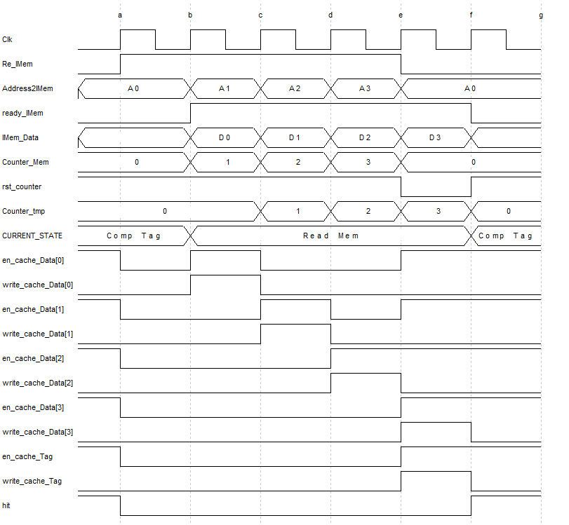

Figure 12: Instruction cache handshaking signals for ideal memory access.

Figure 13 shows handshaking signals for following conditions:

Cache line (block) size: two 32-bits instructions

Main Memory: Non ideal, 32 bits width

Syncram: 16 bits width

Number of instruction memory refers is equal to two (Num_IMem_Refer=2). 4 syncram is needed to cover a cache block (IC_Num_Data_Mem=4).

1. Address of first instruction is sent to memory. Cache informs memory by raising read memory signal (Re_IMem=1).
2. Memory responds with returning first instruction (D0) and raising strobe signal (ready_IMem=1). To store instruction into cache two syncram should be enabled (en_cache_Data[0,1]=1 , write_cache_Data[0,1]=1) at the same time (Reminder: instruction length is 32 bits and each syncram width is 16 bits). Request for next instruction (A1) is sent by still driving Re_IMem signal.

e) Memory responds (D1) after two clock cycle delay. Syncram third and fourth in Data part of cache capture the instruction (en_cache_Data[2,3]=1 , write_cache_Data[2,3]=1). Counter resets for next usage. Tag is updated (en_cache_Tag=1, write_cache_Tag=1). Finally to read cache line all syncrams in Data part of cache are enabled.

f) Because Tag part matches with PC tag hit happens. Tag is enabled to pave the way for comparing next PC. In parallel Data part of cache is also enabled to load a cache line. If the next PC comparing hits, loaded cache line will be used to find instruction in need else it will be ignored.

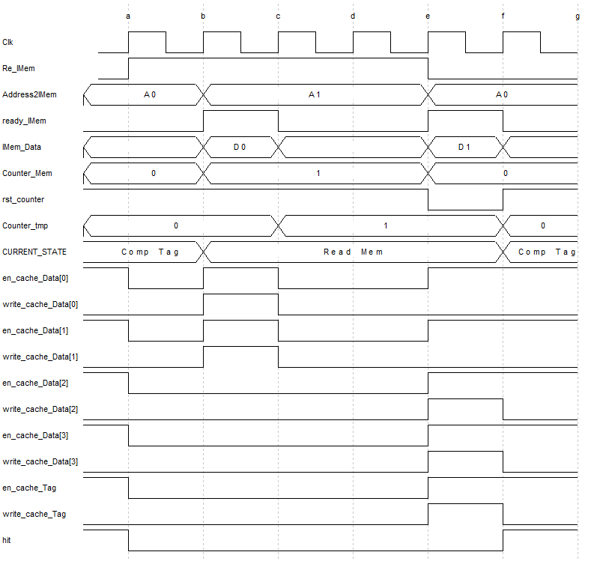

Figure 13: Instruction cache handshaking signals for non-ideal memory access.

# Data Cache

By now reader is familiar with instruction cache and its functionality both in controller and datapath parts. We take the same approach in explanation for data cache as well. Comparing Figure 14 with its counterpart in Figure 7, the main difference in datapath of data cache is in DirtBit_Mem. Therefore most of the dissimilarities lay on controller and its control signals. Also one important issue that reader should be aware of is that processor request is not only reading data from memory but sometimes it writes data into memory (comparing to operation for instruction fetching which is always reading from memory).



Figure 14: Data cache modules hierarchy.

## Controller

Data cache controller can be a little complex to grasp at first glance. It is recommended to first read and get comfortable with instruction cache. The order we discuss data cache controllers is from easy one to complex one which is: write through with no allocation, write through with allocation and write back with allocation. In addition a flowchart comes with each case to make understanding easier.

### State transition

Before going through the details of controller, let’s look at state change by considering Figure 15 flowchart. Controller is nothing more than this flowchart.

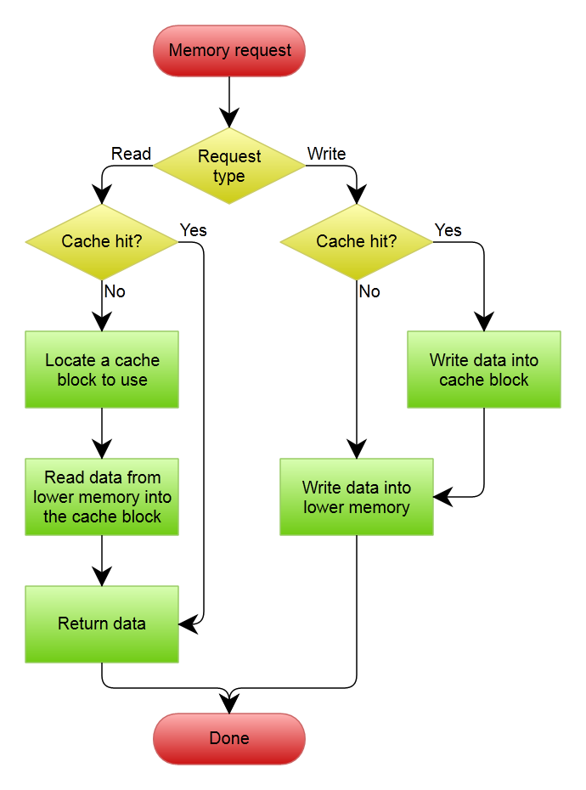

Figure 15: Write through with no write allocation flowchart.

Following data cache controller with write through with no allocation policy is described. As it is depicted in Figure 16, flushing operation is similar to the one mentioned for instruction cache. Despite instruction cache, after flush state, data cache goes to Idle state and waits for request from processor (Hint: data cache would not be accessed as frequently as instruction cache and having an Idle state in data cache is a logical assumption). As soon as there is a request for reading or writing from processor (CPU_Re_Comb=1 or CPU_Wr_Comb=1) data cache state will change to comparing tag state (Comp_Tag). Here we should mention that signals which will be used by external memory are CPU_Re and CPU_Wr that is produced by registering CPU_Re_Comb and CPU_Wr_Comb respectively. The reason for controller to use read and write signals that are produced one clock cycle ahead is to compensate for one clock cycle delay of controller to wake up out of Idle state. For both read and write operations, first data cache should be checked to find if the requested data resides in it or not. Now assumes data does not reside in cache i.e. a miss happens (hit=0). Depending on processor operation is read or write, different path is taken by controller. First we consider read operation causes miss. This leads to cache controller changes its state to Read_Mem to load a block from memory. The signals should be issued before going to Read_Mem are:

Re_DMem: To command memory for reading.

en_counter_Mem: This counter will be used both to keep track of how many accesses to memory is needed before deactivating cache request and also as offset to produce consecutive addresses inside a memory block which should be loaded to a cache line.

Mem_Acc_Finished: Before going to reading from memory, controller should alert arbiter that memory is occupied by data cache.

Ready_DCache: Since miss happened, controller should inform outside world which are depending on data cache result (processor/instruction cache) of this fact.

Needless to say that prior to loading from memory an empty block should be available in data cache. After reading from memory if next instruction in program flow is also load from memory, controller changes its state to comparing tag otherwise it will go to Idle state and waits for memory operation. It is worth mentioning that during transition from Read_Mem to Comp_Tag state tag and data part of cache is enabled to make the foundation for comparing next PC tag.

Now assumes the operation which caused miss to happen is write operation. Since our policy here is write through with no allocation, controller changes its state to write directly into memory (Wr_Mem) without bothering for cache update. The signals which should be issued during transition from Comp_Tag to Wr_Mem are as follow:

Wr_DMem: Write command to data (main) memory.

ready_DCache: It indicates processor/instruction cache that data cache is not ready yet.

Mem_Acc_Finished: Since data cache is going to use the memory in next clock cycle/cycles, this flag is deactivated to inform arbiter that memory is no longer available for scheduling.

As long as data memory is not ready (ready_DMem=0), controller stays in Wr_Mem state and issues the same control signals mentioned above.

Another possibility is to have hit from beginning (When controller is in Comp_Tag state). If the CPU request is read operation, the line that has been read from cache memory during transition from Idle to Comp_Tag will be used by processor (Hint: As it can be seen during transition from Idle state to Comp_Tag, the data part of cache is enabled to read a cache line. In other words en_cache_Data=”11…1”). In case processor operation is write and hit happens, first the specific part of cache line should be updated by going to Upda_Cache. During transition from Comp_Tag to Upda_Cache control signals of specific word in cache line is issued. Since writing to cache should be transparent with memory, after updating cache the data should also be written to main memory. This happens by going to Wr_Mem state.

One transition that is not covered in explanation is from Comp_Tag to Idle state. If current request of processor hits and there is no instruction that access memory immediately after the current instruction (CPU_Re_Comb=0 and CPU_Wr_Comb=0), data cache will go to Idle state.

Another issue which may catch your attention is Extr_Stall signal functionality and the reason not going to Comp_Tag state although we have processor request (CPU_Re_Comb=1 or CPU_Wr_Comb=1). Before going to answer it, we should be aware of this fact that controller uses combinatorial signals for read and write to decide about cache operation one clock cycle ahead of time. This means that before processor address request reaches cache input, controller knows one clock cycle ahead that there will be a request by processor. Assumes suddenly a stall happens in processor (Extr_Stall=1). If controller changes to Comp_Tag only based on (CPU_Re_Comb=1 or CPU_Wr_Comb=1), that means cache starts operating without having a correct address at its input (Hint: Since processor stalls address will not reach cache input). Therefore whenever an external stall happens (Extr_Stall=1), controller should remain in Idle state.

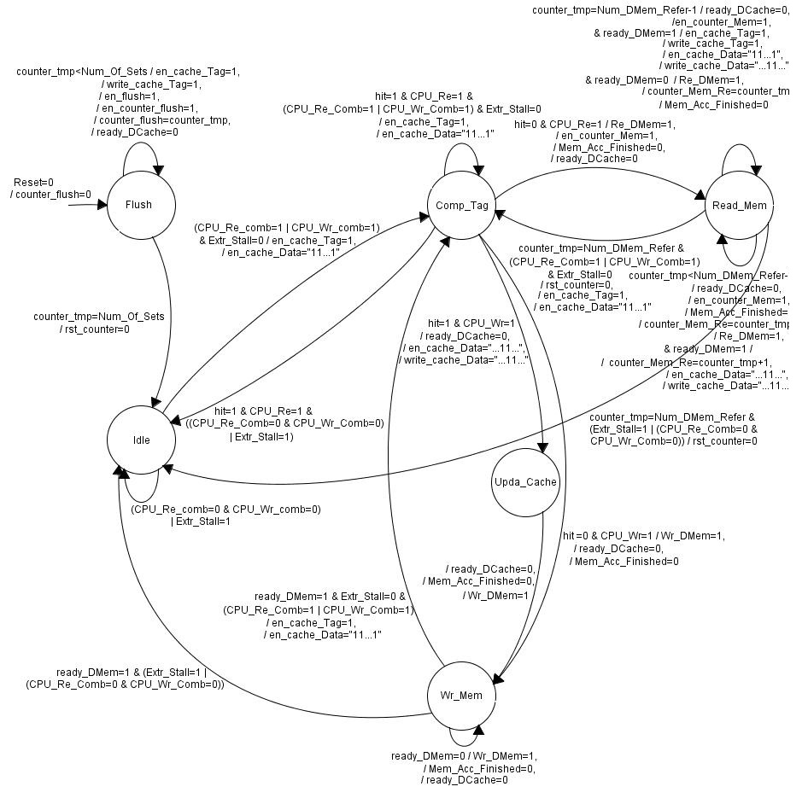

Figure 16: Data cache write through with no allocation FSM.

In Figure 17 the controller for write through with allocation is sketched. Comparing with previous figure most of the transitions seem similar. Therefore here we only address the differences. Since write policy obeys allocation, in case a miss happens (no matter if it is caused by store or load instruction) controller always go to Read_Mem state to locate and load cache block from memory. After finishing with reading from memory if the request comes from load instruction, controller goes to Comp_Tag otherwise if the request comes from store instruction it will change to update cache state (Upda_Cache). It is obvious that there should be no direct transition from Comp_Tag to Wr_Mem state.

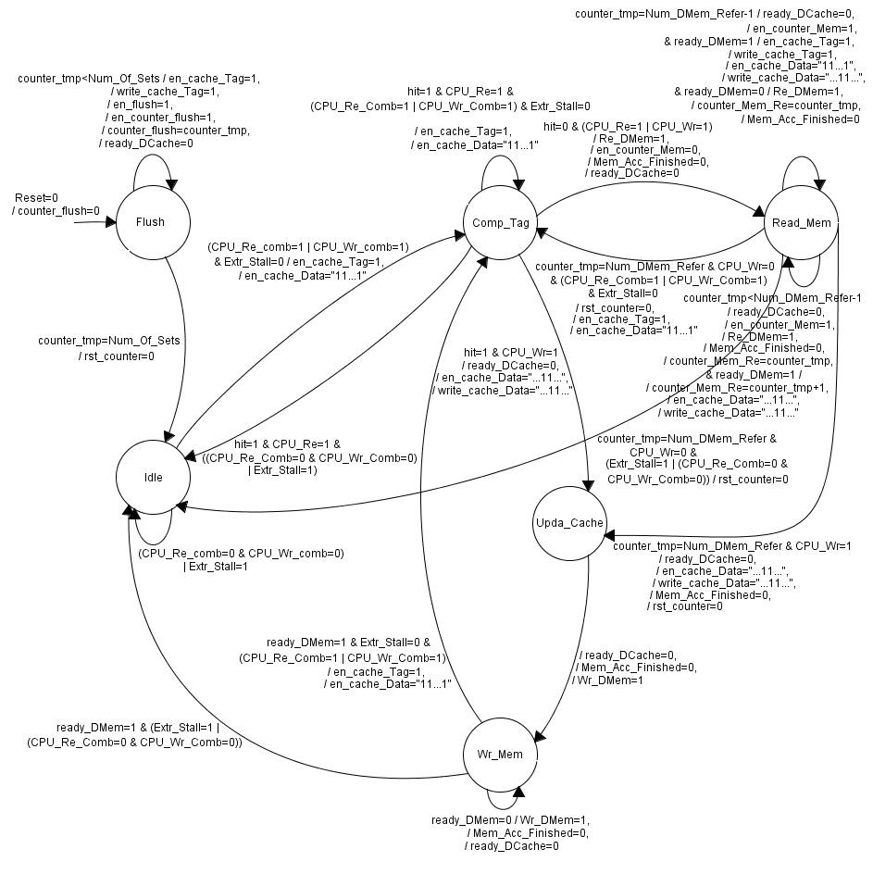

Figure 17: Data cache write through with allocation FSM.

Like write through policy for write back policy a flowchart in Figure 18 is provided to make reader familiar with algorithm before delving into controller explanation. Write back policy gives the opportunity of postponing memory access as far as possible. Hence instead of writing directly into memory the data stores into data cache until there is no empty space for a specific block. At this moment data must transfer to main memory to open room for new data. To keep the record of which cache blocks should be written back into memory a status bit is necessary for each cache line. These bits are stored in a separate memory with the name dirty bit.

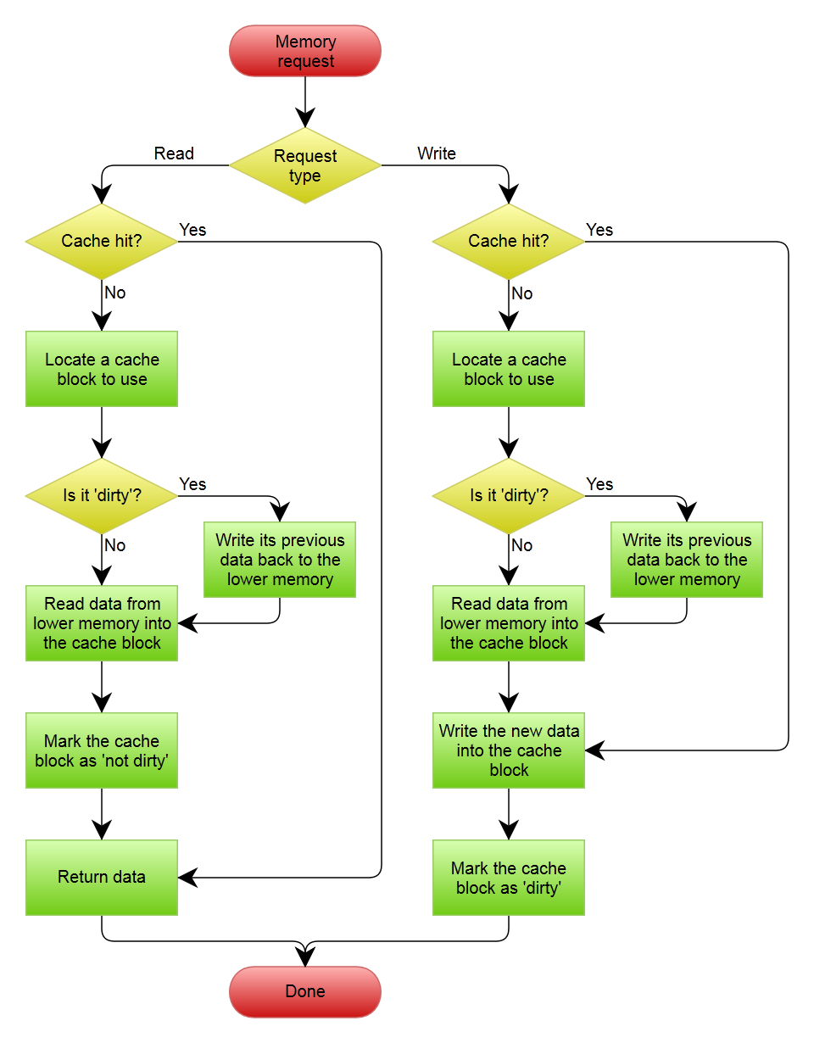

Figure 18: Write back with write allocation flowchart.

Since Flush, Idle and Comp_Tag states and their transitions are similar to previous cases, we continue our explanation from Comp_Tag state. Assume load or store instruction is executed by processor and now it is in memory stage and a miss happens. Therefore cache should locate a place to load from memory. If the victim cache line is dirty (DirtBit_DataO=1) first it should be written back to memory (Wr_Back state). The process of writing back to memory, like reading from it, takes several iterations as it is shown by loop transition over Wr_Back state. The signals that are issued before going to Wr_Back state is as follow:

ready_DCache: By zeroing this signal, processor knows that data cache is in middle of operation.

Mem_Acc_Finished: Signals arbiter since memory will be grabbed by data cache in next state.

Wr_DMem: To command data memory for writing into it.

WrBack: To understand the reason for having this signal a review on memory address production by cache is necessary. When cache gets the read request from processor by receiving memory address which belongs to specific word (or half word) and a miss happens, it should load not only that word but also its neighboring words. Therefore cache uses a counter as an offset to produce word addresses for a whole memory block. Now the similar thing should happen when write back happens but this time cache should write back a whole cache block into memory. Since part of the write address is stored as tag inside cache first cache should retrieve tag part of cache line and then combine it with index of the row and block offset (which generates by a counter). As it is deductible by explanation, the origin of memory address during write into memory is different from when read happens (The former comes from cache and the latter from processor). With this long explanation we are ready to know why WrBack control signal is needed (if you have not get it until now!). It works as select signal of a multiplexer to steer between read and write memory addresses.

After writing back to memory the victim line will be replaced by new values from external memory during Read_Mem state. By now if CPU request was reading from memory (load) the task is complete. It is worth mentioning since dirty cache line is written back into main meory, the dirty bit should be erased. This happens by issuing following signals during transition from Wr_Back to Read_Mem state:

en_DirtBit: it enables dirty bit memory for writing.

DirtBit_DataI: Determines the value which should be written into dirty bit memory.

After finishing with Read_Mem state, If next instruction of processor also has data memory operation (CPU_Re_Comb=1 or CPU_Wr_Comb=1) next state will be Comp_Tag else controller changes to Idle state.

Another scenario is that CPU had a write operation therefore Read_Mem is not final state. In this case after reading from memory, part of cache line should be updated by CPU data (It can be a word, half word or byte). Upda_Cache is last state to complete CPU write request (store). During transition to update cache state dirty bit should be updated to know that line is dirty. If next instruction also needs to do data memory operation (CPU_Re_Comb=1 or CPU_Wr_Comb=1), controller changes to Comp_Tag else it goes to Idle state and waits for another CPU read or write request.

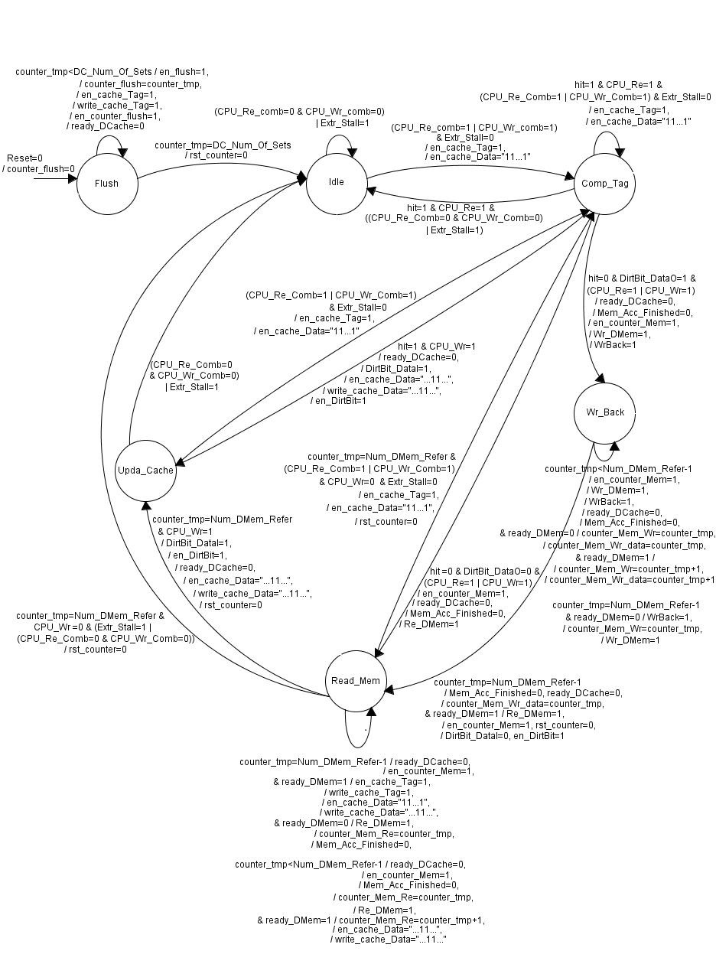

Figure 19: Data cache write back with allocation FSM.

## Memory hand shaking signals-read operation

For data cache both read and write operations are possible. Read operation for two different senarios is explained in this part. Next part deals with write operation.

Figure 20 illustrates handshking signals considering following conditions:

Cache line (block) size: four 32-bits data words

Main Memory: Ideal, 32 bits width

Syncram: 32 bits width

Missing word: Stores in first Syncram (cache line offset of zero)

Based on cache line size and main (data) memory width it can be infered that four access to memory is needed to load a block (Num_DMem_Refer=4 ). Since cache line size is 128 bits, 4 syncram should be used (DC_Num_Data_Mem=4).

Assume a write miss happens and data cache obeys write allocation policy. As a result missing block will be loaded into cache first and then one of its data is overwritten by data from CPU (Upda_Cache state).

1. Next_STATE changes from compare tag to read memory state and address of first instruction in the block (A0) alongside memory read (Re_DMem=1) signal is sent to memory. Counter_Mem_Re signal is used to produce offset for memory addresses.
2. CURRENT_STATE changes to Read_Mem state. Since memory is ideal, without any delay first data is ready (D0) and ready signal (ready_DMem) is raised to inform cache of this fact. As soon as first data arrives enable and write signal (en_cache_Data[0] , write_cache_Data [0]) of first syncram in cache will be activated to store data into Data part of cache. At the same time address for second data (A1) in the block will be sent to memory.
3. Main memory responds with second data (D1) and cache activates corresponding syncram (en_cache_Data[1] , write_cache_Data [1]) to store it. By changing address to A2, cache requests for next data in the block.
4. Same as c with only difference in enabling syncram which in this case is third one. (en_cache_Data[2] , write_cache_Data [2])
5. Last data of block (D3) is received by cache consequently request from memory deactivates (Re_Dmem=0). The last syncram is enabled (en_cache_Data[3]=1 , write_cache_Data[3]=1) to capture last data. Cache TAG is updated (en_cache_Tag=1 , write_cache_Tag=1). Also whole cache line (en_cache_Data[0,1,2,3]=1) is enabled to read updated block.

One difference that can be noticed in this diagram with its counterpart for instruction cache is additional clock cycle for Read_Mem state. To explain the reason for this difference a review on read miss and write miss is necessary.

Read Miss: Processor wants an instruction or data but it cannot find it in cache (As a result cache requests memory for that instruction or data on behalf of processor).

Write Miss: This is applicable only to data cache with write allocation since instruction cache never tries to write into memory. Now assume that processor wants to write a data into memory. Here two options are likely. If the block that data belongs to is already available in data cache (hit), processor writes both in cache and memory. But if block is not in the cache (miss) now it depends on cache policy either to ask memory for it and then update it with processor data (Write allocation) or doesn’t bother loading the block into cache and only write processor data into memory (No write allocation).

As mentioned in assumptions for Figure 20, data cache supports write allocation. Now with this long preface let’s return back to find out the difference.

For instruction cache reading from memory serves a read miss in contrast reading serves write miss for Figure 20 scenario. In other words in instruction cache waveform next state after Read_Mem is Comp_Tag but here it changes to Upda_Cache. During update cache state a data from processor would be written into selected part of cache line. Also in the last cycle of Read_Mem state last data from memory is written to cache. In case of not having additional clock cycle for Read_Mem state there would be a conflict between Upda_ Cache write and Read_Mem state write.

1. Since we assumed data from processor should go to first offset of cache line, enables for first syncram is activated (en_cache_Data[0] , write_cache_Data [0]).
2. ready_Dcache signal is raised to indicate that write miss is handled successfully by data cache and processor can proceed its execution.

It is worth noticing that before clock cycle with label a, CURRENT_STATE is Idle and all the enable signals for tag and data part of cache are activated. This way next clock cycle comparing can be handled.

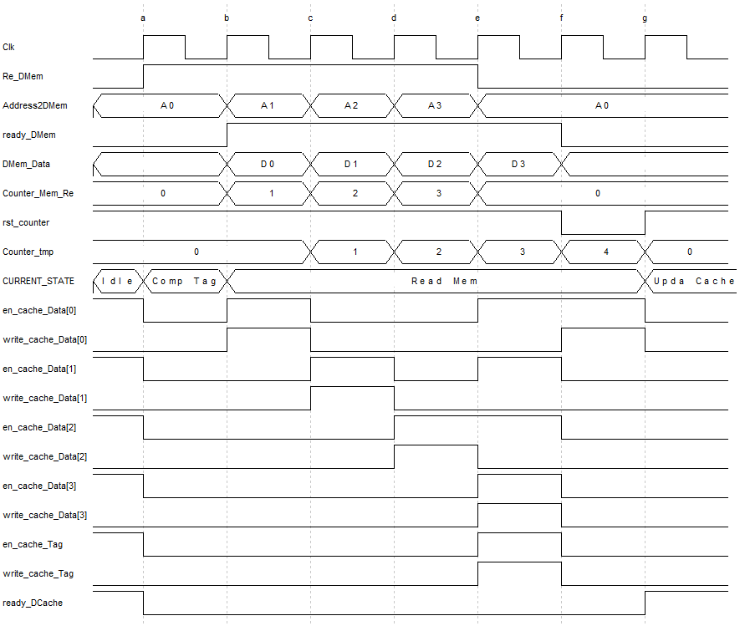

Figure 20: Data cache handshaking signals for ideal memory read.

Figure 21 shows waveform signals for following conditions:

Cache line (block) size: two 32-bits data words

Main Memory: Non-ideal, 32 bits width

Syncram: 16 bits width

Missing Word: Belongs to third and fourth Syncram (Last offset in cache line)

Since until now you get familiar with most of the details of handshaking signals, only differnces will be highlighted in explanations.

Syncram width is 32 bits and to hold a data coming from memory two of them should be enabled at the same time. In addition because of memory delay, after one clock cycle cache receives second (D1) data. The word offset which should be updated by processor is last word in cache line (Hence in clock cycle with label e write_cache_Data[2,3] equals to one).

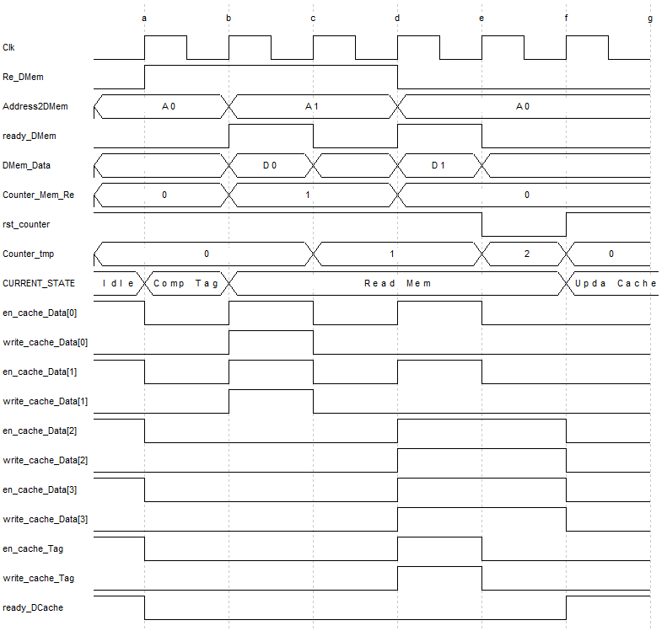

Figure 21: Data cache handshaking signals for non-ideal memory read.

## Memory hand shaking signals-write operation

As last attempt to learn about handshaking of memory and cache, we take a look at a more difficult example that contains writing back to memory. As usual first example is for an ideal memory and second for non-ideal one.

In Figure 22 handshaking signals for data cache with write back with allocation policy is depicted. Following conditions for memory and cache are assumed:

Cache line (block) size: Four 32-bits data words

Main Memory: Ideal, 32 bits width

Each Data syncram: 32 bits width

One logical conclusion from above conditions is Num_Dmem_Refer=4. It is needless to say that every write back operation would be followed by reading from memory (reminder: write back makes a place empty for a new block from memory). Explanations below comes in chronolgical order based on processor clock cycle:

1. Address of first data (in block) alongside its data (D0) is sent to main (data) memory. Wr_DMem signal is raised to order memory for write operation.
2. ready_DMem is raised by main memory to indicate that first data is written successfully. Consequently data cache provides address for second data (A1) and its content (D1).
3. It’s the same as b but instead this time for third data.
4. It’s the same as b but instead this time for fourth data.
5. ready_DMem shows that last data received by main memory successfully. As a result Wr_DMem is set to zero to terminate write request. Counter is reset to make it ready for next operation which is reading from memory. Re_DMem is activated to ask for first data of new block.
6. Memory responds with first data of new block (DMem_Data=D0). Read_Dmem is raised to notify data cache of this fact. At the same time data cache enables first offset (en_cache_Data[0]=1, write_cache_Data[0]=1 ) of its Data part to capture data coming from memory.

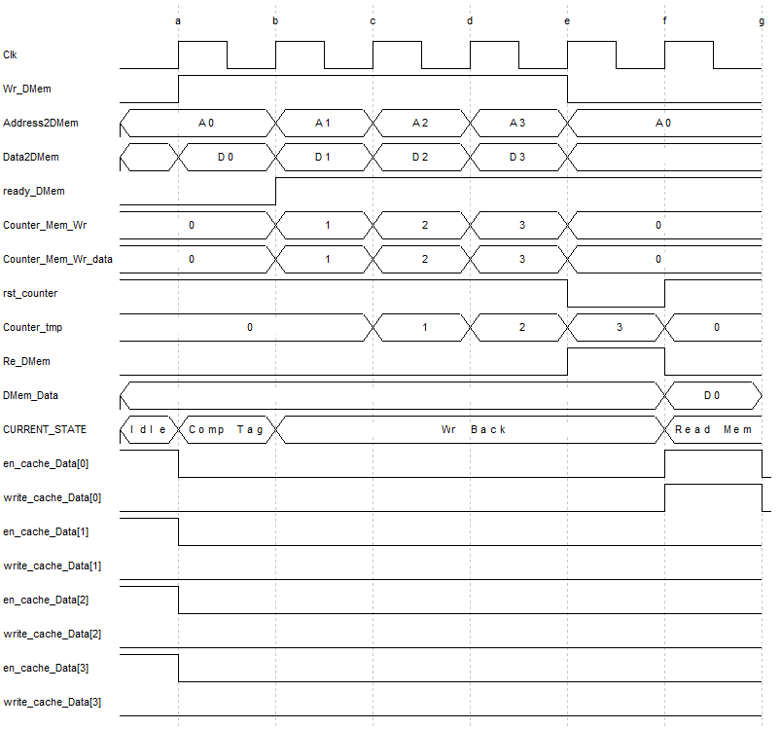

Figure 22: Data cache handshaking signals for ideal memory write.

Figure 23 is basically the same operation as Figure 22 with only differnces in cache line size (here it is smaller than previous one) and memory that is not ideal.

Cache line (block) size: two 32-bits data words

Main Memory: Non-ideal, 32 bits width

Each Data syncram: 32 bits width

Number of memory refers can be infered as: two (Num_Dmem_Refer=2).

The important point should be noticed here is that address offset and data offset are not synchronized like previous example (Counter_Mem_Wr is address offset and Counter_Mem_Wr_data is data offset). The reason is that data cache should not remove data from line until main (data) memory lower down its ready signal (clock c).

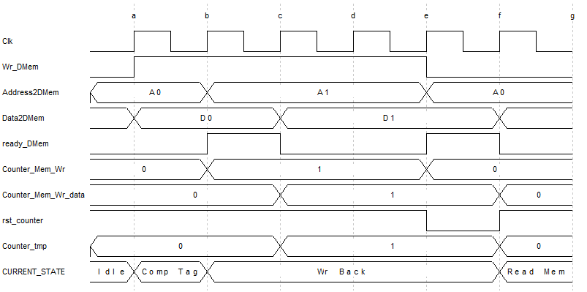

Figure 23: Data cache handshaking signals for non-ideal memory write.

# Arbiter

To be able for caches to access a single memory unit, arbiter module is unavoidable. As long as only one cache has memory request it will be fulfilled as a regular request without arbiter. In case of request by both caches the one with earlier request will get the memory attention (First come, first served policy).

## Controller

Arbiter controller is composed of a 3 states FSM. It is a moore machine. The states and transitions are described as bellow:

NoMemAcc: As the name indicates in this state none of the caches requests memory access. If data cache requests a memory operation (read/write), controller will change its state to DataMemAcc and DataOrInstr output will be equal to one for data cache to be able driving main memory ports. Also if there is a request from instruction cache to read form memory (IC_Mem_Re=1), next state will be InstrMemAcc and DataOrInstr output will be equal to zero for instruction cache to be able driving main memory ports. In case of no request from both caches it will remain in the NoMemAcc state which is shown by the loop transition in the Figure 24.

DataMemAcc: In this state memory is busy with the request of data cache. Controller will remain in this state until memory access by data cache ends (DC_Mem_Acc_Finished=1). After data cache request is fulfilled by memory if instruction cache needs memory (IC_Mem_Re=1) next state will be InstrMemAcc else controller changes to NoMemAcc state and waits for a memory request by one of the caches.

InstrMemAcc: In this state instruction cache reads from memory. Controller will remain in this state until memory access by instruction cache ends (IC_Mem_Acc_Finished=1). Then before returning to NoMemAcc state, controller checks if data cache wants to do memory operation (DC_Mem_Re=1 or DC_Mem_Wr=1). If so it changes to DataMemAcc state else controller goes to NoMemAcc state and waits for another memory request by one of the caches.

Note: In case of simultaneous request for memory from both caches it is possible to give the priority to any of the caches in MIPS processor (Since MIPS processor will be stalled no matter instruction or data is missing).

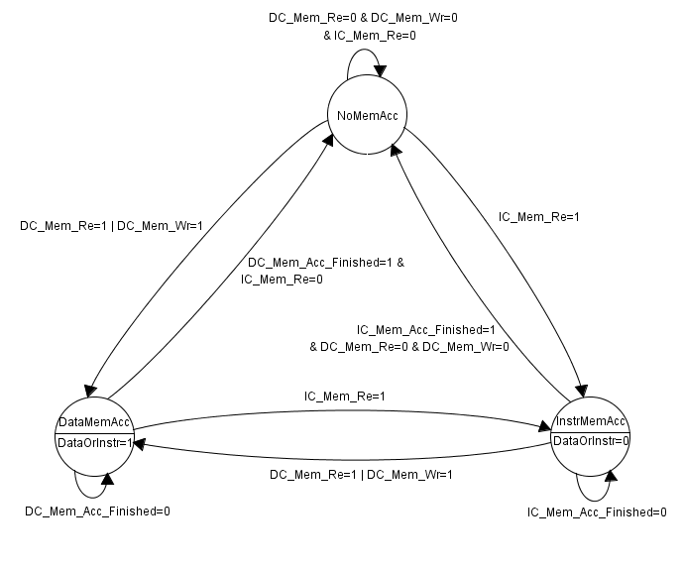

Figure 24: Arbiter controller FSM.

## Datapath

Arbiter datapath is composed of bunch of multiplexers that steer inputs from caches to output (which is connected to main memory) and vice versa. Select signals for multiplexer comes from control unit of arbiter.

Signals to arbiter are described as below:

Following naming convention would make it easier to find origin of signals: signals that start with capital letter D, I and M are coming from data cache, instruction cache and main memory respectively.

Input signals to arbiter:

DMem_Addr: This signal comes from data cache and denotes address of main memory. Arbiter chooses between this signal and IMem_Addr.

IMem_Addr: This signal comes from instruction cache and it will be used as main memory address. Arbiter chooses between this signal and DMem_Addr.

DataOrInstr: This signal comes from arbiter controller and will be used as select signal to multiplexers of arbiter. If it is equal to one, values related to data cache will be sent to main memory and if it is zero, instruction cache values will be chosen.

DMem_DataI: This signal comes from data cache and indicates input data to main memory. Since instruction cache never writes to memory there is no counterpart for this signal in instruction cache.

Mem_DataO: Main memory returns data through Mem_DataO.

DMem_Re: This signal comes from data cache. It enables reading from main memory. Arbiter chooses between this signal and IMem_Re.

IMem_Re: This signal comes from instruction cache. It enables reading from main memory. Arbiter chooses between this signal and DMem_Re.

DMem_Wr: This signal comes from data cache. It is used as a command to write into main memory. Since only data cache writes into memory there is no counterpart for this signal in instruction cache.

Mem_Ready: This signal comes from main memory. After requested cache operation (read/write) is done by main memory, this signal will be activated.

DMem_Mask: This signal comes from data cache. To write a byte or half word into a word addressable memory using memory mask is essential.

Output signals from arbiter:

Mem_Addr: This signal goes to main memory. Data or instruction address will drive this signal depending of multiplexer select signal (DataOrInstr).

Mem_DataI: This signal goes to main memory. Input data to main memory that comes from data cache (Reminder: instruction cache never writes into memory).

DMem_DataO: This signal goes to data cache. After arbiter receives data form main memory, if DataOrInstr select signal equals to one arbiter will send the data to data cache.

IMem_DataO: This signal goes to instruction cache. After arbiter receives data form main memory, if DataOrInstr select signal equals to zero arbiter will send the data to instruction cache.

Mem_Re: This signal goes to main memory. It enables memory for reading operation.

Mem_Wr: This signal goes to main memory. It enables memory for writing operation.

DMem_Ready: This signal goes to data cache. It notifies data cache that requested operation (read/write) has been done successfully by memory.

IMem_Ready: This signal goes to instruction cache. It notifies instruction cache that requested operation (read) has been done successfully by memory.

Mem_Mask: This signal goes to main memory. After arbiter receives mask through DMem_Mask, based on type of memory mask (binary/hexadecimal) it issues a modified mask to main memory.

# System context and cache models

As it is illustrated in Figure 28 caches communicate with processor (For main tests we used MIPS) through some handshaking signals. Since there is only a single DDR memory unit (Von Neumann architecture), there should be arbitration between instruction and data cache requests.

One aspect that should be respected in any generic model design is its usability and learnability for a third party user. One approach that makes it easier to understand signal interface between two components is encapsulation method. As it is illustrated in Figure 25 input signals from caches to processor and vice versa are collected in bunch of VHDL records. As an example CPU_LS_out record contains: address, data and some control signals such as read/write command and memory mask. To be able employing caches in a single unit memory environment an arbiter is developed. On one side arbiter communicates with processor using some control signals and on the other side it has the task of arbitration between caches to access external memory.

Since arbiter should synchronize caches with processor, it gets the request from both caches and processor resorting to IC_out, DC_out and CPU_Hazard signals. If there is a data hazard from processor, arbiter issues an external stall to instruction cache. Through this external stall instruction cache holds its current status until hazard resolves. The data hazard will not be sent to data cache since data cache is one of the components which should continue execution to help processor hazard resolves. In addition arbiter asserts stall (CPU_stall) to processor. If one of the caches is not ready with requested data, processor is stalled.

As mentioned above and can be seen from Figure 28 the other side of arbiter is connected to main memory. If only one of the caches have memory request, arbiter grant access to memory immediately. In case of simultaneous request from both caches, data cache is given priority over instruction cache.

For testing our system model with a DDR memory model, we used an AHB bus. Arbiter resides at one end of AHB as one of the masters. At the other end DDR controller exists as slave of the bus. To connect arbiter to AHB we used some glue logics to translate signals into ones compatible with AHB. To check what values are being written into memory a parallel UART port is employed which is connected to AHB through an AHB/APB bridge. It worth mentioning that AHB/APB Bridge is master for APB and at the same time is slave for AHB. We were able to reduce development time thanks to third party open core peripherals.



Figure 25: General system level block diagram.

## AMBA

Note: The goal of this part is not to describe AMBA bus operation. One can refer to AMBA specification for details [6]. Here you can find a review of important aspects of bus function and description of important signals that are used for our system development of caches.

AMBA is an open standard bus protocol developed by ARM Ltd Company to be used in system on chip designs. An open core implementation of AMBA bus is developed by Gaisler research group which we will use in our design. Therefore it is recommended to take a look at GRLIB IP core user’s manual which can be found in bibliography section [4] and [5].

Two protocols of AMBA which is exploited in our design are: AHB and APB. AHB is used for high performance system modules. Comparing to AHB, APB is for low bandwidth control accesses which is suitable for peripheral components. It also has low power capability.

AHB supports multiple masters and multiple slaves. To set the number of masters and slaves, nahbm and nahbs VHDL constants are used respectively. Having multiple master means there is a need for arbitration between them. Also to choose between multiple slaves the one that is intended listener there should be a decoder module. Finally the task of steering data between multiple masters and slaves is done by using bunch of multiplexers. All of the previous mentioned modules are combined in a single component in GRLIB with the name of ahbctrl (Refer to Figure 26 for clarification).



Figure 26: AHB controller [4].

As shown in Figure 28 in our design we only have one master (nahbm=1) connected to AHB which is cache arbiter. In addition DDR memory controller and AHB/APB bridge are two slaves (nahbs=2) that are connected at the other end of AHB. Based on address request from AHB master one of the slaves or both can be selected.

To handle many signals coming from/going to masters, signals are collected in a VHDL records with the names of ahbmo and ahbmi respectively. In case of having more than one master, a vector of ahbmo is required. As an example ahbmo(2).haddr refers to output address signal from master with index 2 (Note: Signals form AHB starts with h prefix compared to APB which begins with p prefix).

Notice that there is only one ahbmi record regardless of how many masters are connected to bus. The reason is that only one master is owner of the bus at a time and although ahbmi is connected to all masters only the one that is granted access to the bus can collect data form ahbmi. Similar explanation as above is applicable to ahbso and ahbsi.

After getting familiar with AHB, now it is easier to understand APB. In contrast with AHB, APB supports only one master which in our design is AHB/APB Bridge. Nslaves VHDL generic is devised for setting the number of slaves which in our design the only APB slave is UART hence nslaves=1.

As it is shown in Figure 27 depending on number of slaves a vector of apbo VHDL records are needed. In contrast with apbo vector since each APB slave will be selected (enabled) when its address range is requested by APB master, there is only one apbi record which is shared between all slaves. It is worth mentioning that AHB/APB Bridge is master for APB and at the same time is slave for AHB.



Figure 27: AHB/APB Bridge [4].

To complete this part some of the important signals of ahbmo and ahbmi records with a brief explanation are listed below:

ahbmo.hwrite: When it is high it indicates a write transfer and when it is low a read transfer will be performed.

Ahbmo.hsize: It shows size of transfer resorting to a bit vector signal. “000”, “001”, “010” is used to denote byte, half word and word transfer respectively.

Ahbmo.hwdata: Data bus that will be used by master during write operation. It is possible to modify the width of it.

Ahbmo.hbusreq: Each master has one bus request signal. All of them go into bus arbiter so it can choose one of the masters based on scheduling algorithm.

Ahbmo.hburst: It indicates what kind of burst operation should be performed by bus. Since we don’t use burst capability of bus, it is set to “000” that denotes single transfer.

Ahbmo.htrans: Defines the transfer type on bus. Since we don’t use burst transfer capability of bus, only two optiones are used for our design. When there is no need of AHB, htrans is equal to Idle. In the case of transferring, htrans changes to NONSEQ type.

Ahbmi.hgrant: It is generated by arbiter to show which master is granted access to the bus.

Ahbmi.hready: When it is high it indicates successful completion of transfer. Besides slave can extend respond time by holding hready low.

Ahbmi.hrdata: Data bus that will be used by slave during read operation. The width can be modifiable.

## DDR Controller and Micron memory

As depicted in Figure 28 DDRSPA which is instantiated in Top_Unit_FPGA module has the responsibility of communication with Micron memory. Since DDR controller is AHB compatible, its connection to AHB bus is not a burden. To learn on how to connect the AHB bus, you can refer to [4].

In contrast, connection of DDR controller to micron memory needs knowledge of DDR memory and its signal ports. Here we don’t want to describe these signals. One can go through Micron memory datasheet for more information.



Figure 28: Detailed system level block diagram.

## Scripts

Compilation of VHDL files, benchmarks, simulation, and synthesis have been done resorting to makefile scripts. Also Git repository used to ease the version control of the project.

## Simulation and Synthesize

To tackle complexity of cache synchronization with processor, a step by step approach is used during development. In first step instruction cache is instantiated stand-alone while an ideal data memory unit is used for data (Without data cache). As a second step only data cache component has been used with an ideal instruction memory dedicated to instructions (Harvard Architecture). Later both caches are instantiated in the same design still exploiting two Ideal memories.

After integration with ideal memory was successful, we tried to test them with a real DDR memory model. Next step was to synthesize the design for Virtex family FPGAs and do post route simulation for verification of functionality. For synthesize we used ISE software by Xilinx.

|  |  |  |  |  |  |  |  |  |  |  |  |  |  |  |  |  |  |  |
| --- | --- | --- | --- | --- | --- | --- | --- | --- | --- | --- | --- | --- | --- | --- | --- | --- | --- | --- |
| Instruction Cache Test | | | | | | | | | | | | | | | | | | |
| Rep. Policy → |  | LRU | | |  | Pseu.  Ran. | | |  |  | LRU | | |  | Pseu.  Ran. | | | Instr.  In  Block  ↓ |
| # of Ways → | 1 | 2 | 3 | 4 | 2 | 3 | 4 | 1 | 2 | 3 | 4 | 2 | 3 | 4 |
| Benchmarks  ↓ |  | | | |  | | |  | | | |  | | |
| Printing 18 | ✓ | ✓ | ✓ | ✓ | ✓ | ✓ | ✓ | ✓ | ✓ | ✓ | ✓ | ✓ | ✓ | ✓ | 2 |
| ✓ | ✓ | ✓ | ✓ | ✓ | ✓ | ✓ | ✓ | ✓ | ✓ | ✓ | ✓ | ✓ | ✓ | 16 |
| Hello | ✓ | ✓ | ✓ | ✓ | ✓ | ✓ | ✓ | ✓ | ✓ | ✓ | ✓ | ✓ | ✓ | ✓ | 2 |
| ✓ | ✓ | ✓ | ✓ | ✓ | ✓ | ✓ | ✓ | ✓ | ✓ | ✓ | ✓ | ✓ | ✓ | 16 |
| Fibonacci | ✓ | ✓ | ✓ | ✓ | ✓ | ✓ | ✓ | ✓ | ✓ | ✓ | ✓ | ✓ | ✓ | ✓ | 2 |
| ✓ | ✓ | ✓ | ✓ | ✓ | ✓ | ✓ | ✓ | ✓ | ✓ | ✓ | ✓ | ✓ | ✓ | 16 |
| CRC | ✓ | ✓ | ✓ | ✓ | ✓ | ✓ | ✓ | ✓ | ✓ | ✓ | ✓ | ✓ | ✓ | ✓ | 2 |
| ✓ | ✓ | ✓ | ✓ | ✓ | ✓ | ✓ | ✓ | ✓ | ✓ | ✓ | ✓ | ✓ | ✓ | 16 |
| eembc  -fft00 | ✓ | ✓ | ✓ | ✓ | ✓ | ✓ | ✓ | ✓ | ✓ | ✓ | ✓ | ✓ | ✓ | ✓ | 2 |
| ✓ | ✓ | ✓ | ✓ | ✓ | ✓ | ✓ | ✓ | ✓ | ✓ | ✓ | ✓ | ✓ | ✓ | 16 |
| eembc  -autcor00 | ✓ | ✓ | ✓ | ✓ | ✓ | ✓ | ✓ | ✓ | ✓ | ✓ | ✓ | ✓ | ✓ | ✓ | 2 |
| ✓ | ✓ | ✓ | ✓ | ✓ | ✓ | ✓ | ✓ | ✓ | ✓ | ✓ | ✓ | ✓ | ✓ | 16 |
| eembc  -viterb00 | ✓ | ✓ | ✓ | ✓ | ✓ | ✓ | ✓ | ✓ | ✓ | ✓ | ✓ | ✓ | ✓ | ✓ | 2 |
| ✓ | ✓ | ✓ | ✓ | ✓ | ✓ | ✓ | ✓ | ✓ | ✓ | ✓ | ✓ | ✓ | ✓ | 16 |
| eembc  -empty | ✓ | ✓ | ✓ | ✓ | ✓ | ✓ | ✓ | ✓ | ✓ | ✓ | ✓ | ✓ | ✓ | ✓ | 2 |
| ✓ | ✓ | ✓ | ✓ | ✓ | ✓ | ✓ | ✓ | ✓ | ✓ | ✓ | ✓ | ✓ | ✓ | 16 |
| eembc  -rgbcmy01 | ✓ | ✓ | ✓ | ✓ | ✓ | ✓ | ✓ | ✓ | ✓ | ✓ | ✓ | ✓ | ✓ | ✓ | 2 |
| ✓ | ✓ | ✓ | ✓ | ✓ | ✓ | ✓ | ✓ | ✓ | ✓ | ✓ | ✓ | ✓ | ✓ | 16 |
| # of Sets → | 2 | | | | | | | | 256 | | | | | | | |  |

Table 4: Instruction cache test.

|  |  |  |  |  |  |  |  |  |  |  |  |  |  |  |  |  |  |  |  |  |  |  |  |  |  |  |  |  |  |  |  |  |  |  |  |  |
| --- | --- | --- | --- | --- | --- | --- | --- | --- | --- | --- | --- | --- | --- | --- | --- | --- | --- | --- | --- | --- | --- | --- | --- | --- | --- | --- | --- | --- | --- | --- | --- | --- | --- | --- | --- | --- |
| Data Cache Test | | | | | | | | | | | | | | | | | | | | | | | | | | | | | | | | | | | | Words  In  Block  ↓ |
| Write Policy → | Write Through No Allocate | | | | | | | | | | | | | | | | |  | Write Through Allocate | | | | | | | | | | | | | | | | |
| Rep. Policy → |  | LRU | | |  | Pseu.  Ran. | | |  |  | LRU | | |  | Pseu.  Ran. | | |  | LRU | | |  | Pseu.  Ran. | | |  |  | LRU | | |  | Pseu.  Ran. | | |
| # of Ways → | 1 | 2 | 3 | 4 | 2 | 3 | 4 | 1 | 2 | 3 | 4 | 2 | 3 | 4 | 1 | 2 | 3 | 4 | 2 | 3 | 4 | 1 | 2 | 3 | 4 | 2 | 3 | 4 |
| Benchmarks  ↓ |  | | | |  | | |  | | | |  | | |  | | | |  | | |  | | | |  | | |
| Printing 18 | ✓ | ✓ | ✓ | ✓ | ✓ | ✓ | ✓ | ✓ | ✓ | ✓ | ✓ | ✓ | ✓ | ✓ | ✓ | ✓ | ✓ | ✓ | ✓ | ✓ | ✓ | ✓ | ✓ | ✓ | ✓ | ✓ | ✓ | ✓ | 2 |
| ✓ | ✓ | ✓ | ✓ | ✓ | ✓ | ✓ | ✓ | ✓ | ✓ | ✓ | ✓ | ✓ | ✓ | ✓ | ✓ | ✓ | ✓ | ✓ | ✓ | ✓ | ✓ | ✓ | ✓ | ✓ | ✓ | ✓ | ✓ | 16 |
| Hello | ✓ | ✓ | ✓ | ✓ | ✓ | ✓ | ✓ | ✓ | ✓ | ✓ | ✓ | ✓ | ✓ | ✓ | ✓ | ✓ | ✓ | ✓ | ✓ | ✓ | ✓ | ✓ | ✓ | ✓ | ✓ | ✓ | ✓ | ✓ | 2 |
| ✓ | ✓ | ✓ | ✓ | ✓ | ✓ | ✓ | ✓ | ✓ | ✓ | ✓ | ✓ | ✓ | ✓ | ✓ | ✓ | ✓ | ✓ | ✓ | ✓ | ✓ | ✓ | ✓ | ✓ | ✓ | ✓ | ✓ | ✓ | 16 |
| Fibonacci | ✓ | ✓ | ✓ | ✓ | ✓ | ✓ | ✓ | ✓ | ✓ | ✓ | ✓ | ✓ | ✓ | ✓ | ✓ | ✓ | ✓ | ✓ | ✓ | ✓ | ✓ | ✓ | ✓ | ✓ | ✓ | ✓ | ✓ | ✓ | 2 |
| ✓ | ✓ | ✓ | ✓ | ✓ | ✓ | ✓ | ✓ | ✓ | ✓ | ✓ | ✓ | ✓ | ✓ | ✓ | ✓ | ✓ | ✓ | ✓ | ✓ | ✓ | ✓ | ✓ | ✓ | ✓ | ✓ | ✓ | ✓ | 16 |
| CRC | ✓ | ✓ | ✓ | ✓ | ✓ | ✓ | ✓ | ✓ | ✓ | ✓ | ✓ | ✓ | ✓ | ✓ | ✓ | ✓ | ✓ | ✓ | ✓ | ✓ | ✓ | ✓ | ✓ | ✓ | ✓ | ✓ | ✓ | ✓ | 2 |
| ✓ | ✓ | ✓ | ✓ | ✓ | ✓ | ✓ | ✓ | ✓ | ✓ | ✓ | ✓ | ✓ | ✓ | ✓ | ✓ | ✓ | ✓ | ✓ | ✓ | ✓ | ✓ | ✓ | ✓ | ✓ | ✓ | ✓ | ✓ | 16 |
| Eembc  -fft00 | ✓ | ✓ | ✓ | ✓ | ✓ | ✓ | ✓ | ✓ | ✓ | ✓ | ✓ | ✓ | ✓ | ✓ | ✓ | ✓ | ✓ | ✓ | ✓ | ✓ | ✓ | ✓ | ✓ | ✓ | ✓ | ✓ | ✓ | ✓ | 2 |
| ✓ | ✓ | ✓ | ✓ | ✓ | ✓ | ✓ | ✓ | ✓ | ✓ | ✓ | ✓ | ✓ | ✓ | ✓ | ✓ | ✓ | ✓ | ✓ | ✓ | ✓ | ✓ | ✓ | ✓ | ✓ | ✓ | ✓ | ✓ | 16 |
| Eembc  -autcor00 | ✓ | ✓ | ✓ | ✓ | ✓ | ✓ | ✓ | ✓ | ✓ | ✓ | ✓ | ✓ | ✓ | ✓ | ✓ | ✓ | ✓ | ✓ | ✓ | ✓ | ✓ | ✓ | ✓ | ✓ | ✓ | ✓ | ✓ | ✓ | 2 |
| ✓ | ✓ | ✓ | ✓ | ✓ | ✓ | ✓ | ✓ | ✓ | ✓ | ✓ | ✓ | ✓ | ✓ | ✓ | ✓ | ✓ | ✓ | ✓ | ✓ | ✓ | ✓ | ✓ | ✓ | ✓ | ✓ | ✓ | ✓ | 16 |
| Eembc  -viterb00 | ✓ | ✓ | ✓ | ✓ | ✓ | ✓ | ✓ | ✓ | ✓ | ✓ | ✓ | ✓ | ✓ | ✓ | ✓ | ✓ | ✓ | ✓ | ✓ | ✓ | ✓ | ✓ | ✓ | ✓ | ✓ | ✓ | ✓ | ✓ | 2 |
| ✓ | ✓ | ✓ | ✓ | ✓ | ✓ | ✓ | ✓ | ✓ | ✓ | ✓ | ✓ | ✓ | ✓ | ✓ | ✓ | ✓ | ✓ | ✓ | ✓ | ✓ | ✓ | ✓ | ✓ | ✓ | ✓ | ✓ | ✓ | 16 |
| Eembc  -empty | ✓ | ✓ | ✓ | ✓ | ✓ | ✓ | ✓ | ✓ | ✓ | ✓ | ✓ | ✓ | ✓ | ✓ | ✓ | ✓ | ✓ | ✓ | ✓ | ✓ | ✓ | ✓ | ✓ | ✓ | ✓ | ✓ | ✓ | ✓ | 2 |
| ✓ | ✓ | ✓ | ✓ | ✓ | ✓ | ✓ | ✓ | ✓ | ✓ | ✓ | ✓ | ✓ | ✓ | ✓ | ✓ | ✓ | ✓ | ✓ | ✓ | ✓ | ✓ | ✓ | ✓ | ✓ | ✓ | ✓ | ✓ | 16 |
| Eembc  -rgbcmy01 | ✓ | ✓ | ✓ | ✓ | ✓ | ✓ | ✓ | ✓ | ✓ | ✓ | ✓ | ✓ | ✓ | ✓ | ✓ | ✓ | ✓ | ✓ | ✓ | ✓ | ✓ | ✓ | ✓ | ✓ | ✓ | ✓ | ✓ | ✓ | 2 |
| ✓ | ✓ | ✓ | ✓ | ✓ | ✓ | ✓ | ✓ | ✓ | ✓ | ✓ | ✓ | ✓ | ✓ | ✓ | ✓ | ✓ | ✓ | ✓ | ✓ | ✓ | ✓ | ✓ | ✓ | ✓ | ✓ | ✓ | ✓ | 16 |
| # of Sets → | 2 | | | | | | | | 256 | | | | | | | | 2 | | | | | | | | 256 | | | | | | | |  |

Table 5: Data cache test for write through policy.

|  |  |  |  |  |  |  |  |  |  |  |  |  |  |  |  |  |  |  |
| --- | --- | --- | --- | --- | --- | --- | --- | --- | --- | --- | --- | --- | --- | --- | --- | --- | --- | --- |
| Data Cache Test | | | | | | | | | | | | | | | | | | |
| Write Policy → | Write Back Allocate | | | | | | | | | | | | | | | | | Words  In  Block  ↓ |
| Rep. Policy → |  | LRU | | |  | Pseu.  Ran. | | |  |  | LRU | | |  | Pseu.  Ran. | | |
| # of Ways → | 1 | 2 | 3 | 4 | 2 | 3 | 4 | 1 | 2 | 3 | 4 | 2 | 3 | 4 |
| Benchmarks  ↓ |  | | | |  | | |  | | | |  | | |
| Printing 18 | ✓ | ✓ | ✓ | ✓ | ✓ | ✓ | ✓ | ✓ | ✓ | ✓ | ✓ | ✓ | ✓ | ✓ | 2 |
| ✓ | ✓ | ✓ | ✓ | ✓ | ✓ | ✓ | ✓ | ✓ | ✓ | ✓ | ✓ | ✓ | ✓ | 16 |
| Hello | ✓ | ✓ | ✓ | ✓ | ✓ | ✓ | ✓ | ✓ | ✓ | ✓ | ✓ | ✓ | ✓ | ✓ | 2 |
| ✓ | ✓ | ✓ | ✓ | ✓ | ✓ | ✓ | ✓ | ✓ | ✓ | ✓ | ✓ | ✓ | ✓ | 16 |
| Fibonacci | ✓ | ✓ | ✓ | ✓ | ✓ | ✓ | ✓ | ✓ | ✓ | ✓ | ✓ | ✓ | ✓ | ✓ | 2 |
| ✓ | ✓ | ✓ | ✓ | ✓ | ✓ | ✓ | ✓ | ✓ | ✓ | ✓ | ✓ | ✓ | ✓ | 16 |
| CRC | ✓ | ✓ | ✓ | ✓ | ✓ | ✓ | ✓ | ✓ | ✓ | ✓ | ✓ | ✓ | ✓ | ✓ | 2 |
| ✓ | ✓ | ✓ | ✓ | ✓ | ✓ | ✓ | ✓ | ✓ | ✓ | ✓ | ✓ | ✓ | ✓ | 16 |
| eembc  -fft00 | ✓ | ✓ | ✓ | ✓ | ✓ | ✓ | ✓ | ✓ | ✓ | ✓ | ✓ | ✓ | ✓ | ✓ | 2 |
| ✓ | ✓ | ✓ | ✓ | ✓ | ✓ | ✓ | ✓ | ✓ | ✓ | ✓ | ✓ | ✓ | ✓ | 16 |
| eembc  -autcor00 | ✓ | ✓ | ✓ | ✓ | ✓ | ✓ | ✓ | ✓ | ✓ | ✓ | ✓ | ✓ | ✓ | ✓ | 2 |
| ✓ | ✓ | ✓ | ✓ | ✓ | ✓ | ✓ | ✓ | ✓ | ✓ | ✓ | ✓ | ✓ | ✓ | 16 |
| eembc  -viterb00 | ✓ | ✓ | ✓ | ✓ | ✓ | ✓ | ✓ | ✓ | ✓ | ✓ | ✓ | ✓ | ✓ | ✓ | 2 |
| ✓ | ✓ | ✓ | ✓ | ✓ | ✓ | ✓ | ✓ | ✓ | ✓ | ✓ | ✓ | ✓ | ✓ | 16 |
| eembc  -empty | ✓ | ✓ | ✓ | ✓ | ✓ | ✓ | ✓ | ✓ | ✓ | ✓ | ✓ | ✓ | ✓ | ✓ | 2 |
| ✓ | ✓ | ✓ | ✓ | ✓ | ✓ | ✓ | ✓ | ✓ | ✓ | ✓ | ✓ | ✓ | ✓ | 16 |
| eembc  -rgbcmy01 | ✓ | ✓ | ✓ | ✓ | ✓ | ✓ | ✓ | ✓ | ✓ | ✓ | ✓ | ✓ | ✓ | ✓ | 2 |
| ✓ | ✓ | ✓ | ✓ | ✓ | ✓ | ✓ | ✓ | ✓ | ✓ | ✓ | ✓ | ✓ | ✓ | 16 |
| # of Sets → | 2 | | | | | | | | 256 | | | | | | | |  |

Table 6: Data cache test for write back policy.

### Performance

Here we will present a basic execution-time evaluation using the RTL models of a processor system consisting of a five-stage in-order MIPS processor, L1 instruction and data caches, arbiter, and AHB interface. A time-accurate RTL model of a Micron DDR memory is also included to estimate the main memory latency. As metric we use the average execution time of the following five benchmarks from the EEMBC benchmark suite [7]: autcor, conven, fft, rgbcmy, and viterb. In terms of cache parameters, instruction and data cache sizes are varied between 512 bytes and 4,096 bytes. The cache-line size is fixed to 32 bytes for all the configurations. Figure 29 shows the average execution time for different cache sizes and associativities. The execution time is normalized to the slowest configuration, that is, the 512-byte direct-mapped cache. As expected, when we increase the cache size, the execution time is decreased since the miss rate is reduced. Increasing the cache size further yields diminishing returns, since the miss rate does not decrease significantly after some point. The 2-way associative cache performs more efficiently than the direct-mapped cache. Again, this is expected, since the miss rate decreases due to fewer conflicts. Due to the variation in application working sets, some benchmarks are more sensitive to the cache size than others. For example, the rgbcmy benchmark experiences only a 14% execution time improvement when the direct-mapped cache is scaled up from 512 bytes to 4,096 bytes, whereas the fft benchmark shows a 73% execution time improvement for the same scaling.



Figure 29: Execution time for different cache sizes and associativities.

Figure 30 shows the average execution time for different data write policies. Only a direct-mapped configuration is shown here, but the trend is similar for higher associativities. Because each store operation causes stall cycles until the data are written to main memory, the write-back policy tends to be faster than the write-through policies. The write-through policy actually gives some execution time benefits for very small cache sizes, since the write-back rate is higher here. Although the execution time penalty of the write-through policy can be somewhat mitigated using a write buffer between main memory and the L1 cache, the write-back policy offers the best performance in most cases, which is in line with other reports. The write-through with no-write-allocate policy has shorter execution time than the write-through with write-allocate policy. This is because the no-write-allocate policy reduces the conflicts in the cache, since the store operations that miss in the cache do not cause any allocation in the cache. As the cache size increases, the miss rate decreases and the reduction in the conflicts decrease. Hence, the advantage of the write-through with no-write-allocate policy diminishes.

There are other parameters that should be considered when deciding the cache configuration in a real system. For example, a decreased miss rate does not only improve the execution time, but it also—due to fewer accesses—reduces main memory energy. Another example is an FPGA platform, in which the SRAM blocks are usually of fixed size. To avoid unused space in the SRAM blocks once the resource allocation has been completed, the cache configuration process should consider how memory blocks are implemented.



Figure 30: Execution time for different write policies and cache sizes.

# Summary

New applications like embedded systems, ultra-low power processors and their power and performance criticality force computer architectures to revisit effectiveness of current parameters considered for cache design. By tuning our cache model for specific set of applications, one can reach a better performance and power usage. Besides with more integration computer architects have more calculation power and storage at their disposal. As it is shown in various publications by considering new configurations the caches would fit much better with these new applications. Until now evaluation of cache configurations has been done mostly resorting to software simulation. With our RTL model in hand, measurements would be more realistic and near to real hardware.

## Future work

Following features can be added to future versions of caches:

Early restart: To resume execution as soon as the missing data/instruction of the cache line is returned, instead of stalling processor for the whole line to be loaded form external memory. Even a complicated approach is to request data/instruction that is needed first and later ask for rest of the block.

Buffering: Buffer data that is going to be written to memory and continue execution, so whenever memory is free we can put data from buffer to it in background as CPU continue its processing.

Non-cacheable: It is possible to avoid caching of non-reusable data by defining some part of memory as non-cacheable region. One example of such locations is memory mapped internal registers of peripherals.

Coherency: It is applicable to a system with multiple caches which accesses a shared memory. There is a need for communication protocols between the cache managers which keep the data consistent.

Replacement policies: It is practical to implement other replacement policies such as: LFU and Pseudo LRU. One implementation of PLRU is with resorting to binary tree as follow:

In the tree-based pseudo LRU (pLRUt) replacement heuristic, Nway-1 bits are used to track the accesses to the cache blocks in a set. For example, in a 4-way set pLRUt track bits B0, B1, B2 are used to form a decision binary tree. The track bit B1 indicates whether two lower cache blocks W0 and W1 (B1=1), or 2 higher cache blocks W2 and W3 (B1=0) have been used recently. The track bit B0 determines further which one of two blocks W0 (B0=1) or W1 (B0=0) have been used recently; bit B2 tracks the access between cache lines W2 and W3. On a cache miss, bit B1 determines where to look for the least recently block, and B0 or B2 determines the least recently used block [8].

Prefetching: To reduce compulsory misses.

# Bibliography

[1] A. Gonzalez, F. Latorre, and G. Magklis, Processor Microarchitecture, An implementation perspective. Morgan & Claypool Publishers, 2010

[2] D. A. Patterson and J. L. Hennessy, Computer Organization and Design: The Hardware/Software Interface. Morgan Kaufmann Publishers, 1998.

[3] Z. Navabi, VHDL: Analysis and Modeling of Digital Systems, McGraw-Hill Professional, 1998

[4] GRLIB IP Library User’s Manual, Aeroflex Gaisler, Jan. 2012, version 1.1.0 - B4113, [Online]. http://www.gaisler.com/products/grlib/grlib.pdf.

[5] GRLIB IP Core User’s Manual, Jan. 2012, version 1.1.0-B4112, [Online]. http://gaisler.com/products/grlib/grip.pdf.

[6] **AMBA** TM Specification, ARM Ltd, May 1999, rev 2.0.

[7] Embedded Microprocessor Benchmark Consortium. [Online]. Available: http://www.eembc.org

[8] A. Milenkovic, M. Milenkovic, and N. Barnes, “A performance evaluation of memory hierarchy in embedded systems,” in Proc. 35th Southeastern Symp. System Theory, 2003, pp. 427–431.

[9] R. Bahar, G. Albera, and S. Manne, “Power and performance tradeoffs using various caching strategies,” in Proc. Int. Symp. Low Power Electronics and Design (ISLPED), 1998, pp. 64–69.

[10] A. Putnam, S. Eggers, D. Bennett, E. Dellinger, J. Mason, H. Styles, P. Sundararajan, and R. Wittig, “Performance and power of cache-based reconfigurable computing,” in Proc. Int. Symp. on Computer Architecture (ISCA), 2009, pp. 395–405.

[11] N. Ickes, Y. Sinangil, F. Pappalardo, E. Guidetti, and A. P. Chandrakasan, ”A 10 pJ/cycle ultra-low-voltage 32-bit microprocessor system-on-chip,” in Proc. European Solid-State Circuits Conference (ESSCIRC), 2011, pp. 159-162

[12] N. Ickes, D. Finchelstein, and A. P. Chandrakasan, “A 10-pJ/instruction, 4-MIPS Micropower DSP for Sensor Applications,” Asian Solid-State Circuits Conference (A-SSCC), 2008, pp. 289-292

[13] T. Sudarshan, R. A. Mir, and S.Vijayalakshmi, “Highly Efficient LRU Implementations for High Associativity Cache Memorys,” in Proc. of 12th IEEE International Conference on Advanced Computing and Communications, 2004, pp. 24–35.

[14] F. Vahid, W. Najjar, and C. Zhang, “A highly configurable cache architecture for embedded systems,” in Proc. 30th Annual International Symp. on Computer Architecture, 2003, PP. 136-146.

[15] R. R. Bani, S. P. Mohanty, E. Kougianos, and G. Thakral, “Design of a Reconfigurable Embedded Data Cache,” International Symp. on Electronic System Design (ISED), 2010, pp. 163-168.